**BERTELSMANN – SCHOLARSHIP - INTRODUCTION TO AZURE APPLICATIONS NANODEGREE PROGRAM**

1. **WELCOME TO THE INTRODUCTION TO AZURE**

**LESSON 1 Welcome to the Bertelsmann Scholarship Program**

**How This Program Works**

# Welcome and Congratulations!

Udacity and Bertelsmann are excited to welcome you to the Technology Scholarship Program powered by Bertelsmann! (Introduction to Problem Solving with Advanced Analytics). Here are some helpful details as you start the program.

## How the Scholarship Foundation works:

The lessons in this Foundation course have been specially designed to prepare you to take the full Predictive Analytics for Business Nanodegree program. We recommend you take the time to go through the carefully prepared lessons, as course completion is required to qualify for a Nanodegree scholarship.

Please note - there will be references to Nanodegree projects and some additional project materials provided. **You will not submit a project as a part of this course**. However, if you are selected as a winner for the full scholarship, you will be required to formally submit all technical projects per the suggested deadlines after you are enrolled in the Nanodegree program.

If you have questions, we encourage you to ask directly in our student community.

**Join the Scholarship Community**

**Join the Scholarship Slack Community** We’ve created a custom Slack workspace for your course classmates and you.

**Did you know? Your participation in Slack is a requirement in order to be selected for one of the full Scholarship Nanodegree seats.**

In this exclusive global student community you’ll be able to collaborate with your peers, give and receive support, and participate in community challenges organized by our Community team that will help you complete your coursework. **Below is the auto-invite link to join the Slack community:**

[Join Slack community by clicking here](https://join.slack.com/t/bertelsmanncloudtrack/shared_invite/zt-j9anwk1x-zoACxfsElC~pYhJ9cmK4nQ)  
Be sure to join Slack using the same email address that you use to log in to your Udacity classroom.

If you’re new to Slack, don’t worry! The Community team has resources, including a Slack orientation, to help you get up to speed quickly!

**Orientation**  
Our Community team will be hosting a live Orientation where they’ll share the eligibility criteria for a scholarship for a full Nanodegree program in your chosen track.

**When**: Monday, December 7, 2020 @ 10 AM PST / 6 PM GMT.  
**Follow this link to attend the Orientation:**  
Link : [https://udacity.zoom.us/j/97626879721?pwd=N3R3Y3RNdDd5THJ0b2kzYUR6bXVwZz09](https://udacity.zoom.us/j/97626879721?pwd=N3R3Y3RNdDd5THJ0b2kzYUR6bXVwZz09" \t "_blank)  
Meeting ID: 976 2687 9721 Passcode: 117031

Orientation will be recorded and posted on the Scholarship Google site for anyone who is unable to attend the live session.

**Scholarship Google Site** The Bertelsmann Technology Scholarship Google site will be your go-to spot for all information about this Scholarship program. Check back often as updates are made regularly. If you have a question, the answer is most likely here!

Link: <https://bit.ly/bertelsmann-scholar>

Happy learning!

1. **INTRODUCTION TO AZURE APPLICATIONS**

**LESSON 1 Introduction to Microsoft Azure Development**

**Meet your instructor**

Chris Vasquez, All-Star UDACITY Curriculum Manager with years of practical experience building courses and also in Azure, will lead us through the course! Chris gained some of his own technical skills through Udacity courses and Nanodegree programs, just as you will.

**Prerequisites**

To succeed in this course, students should have experience in the following areas:

* Python (1-3 years of programming experience preferred), with experience building Flask apps
* SQL Server or MySQL to store and query data (you can get by with other SQL flavors as well)
* Using Git to pull and push code

**Lesson Outline**

This lesson will focus on the following topics under Microsoft Azure Cloud Development:

* Why cloud computing is important, when to use it, and who are the key stakeholders
* History of *the cloud*
* Microsoft Azure and Azure Portal
* Comparing cloud service types (such as Infrastructure as a Service, Platform as a Service, and Software as a Service)
* Tools and environment set up for the course
* The final course project

**Course Outline**

The course is divided into 3 major sections - Azure Compute Services, Storage Options in Azure, and Security, Monitoring and Logging.

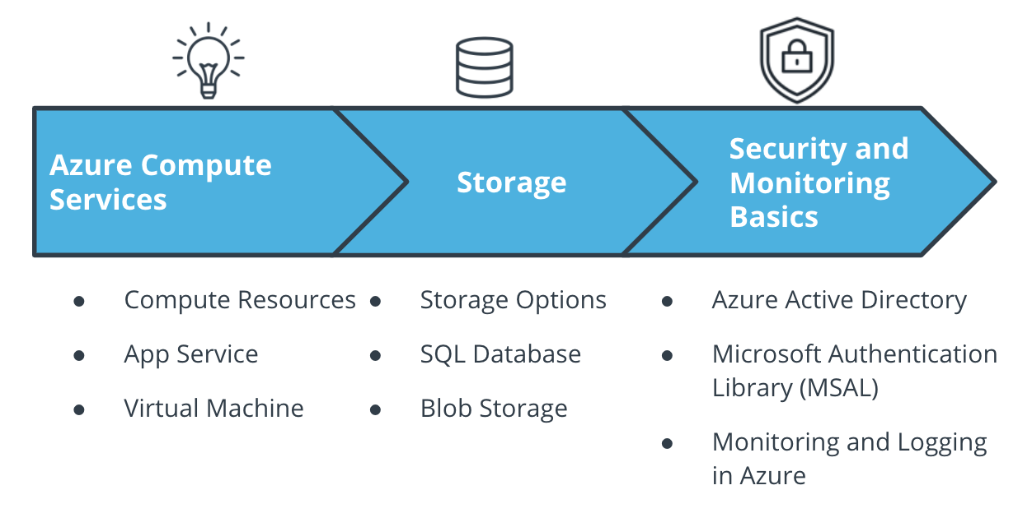

The Course Outline

**Introduction to Cloud Development**

**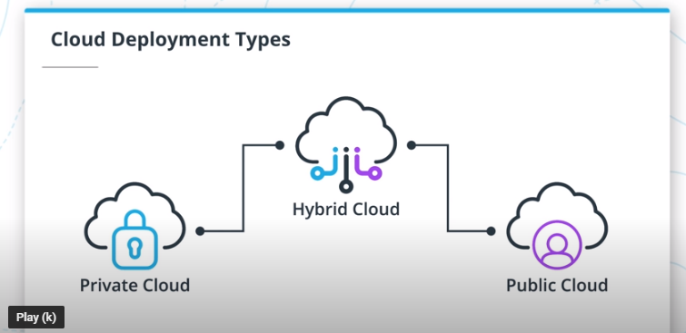**

The **cloud** is a collection of servers on the internet that store and manage data, run apps, and deliver content such as email or videos. **Cloud computing** is the delivery of software and storage over the Internet (i.e. *the cloud*).

Some of the benefits of using cloud computing are:

* Cost
* Scale
* Reliability
* Security

The three major types of cloud services are **Public**, **Private**, and **Hybrid** cloud. The major differences between these are in where they are deployed, and who manages them. Microsoft OneDrive, Microsoft Azure, and Microsoft Office365 are examples of public cloud options.

Cloud Developers perform some of the following:

* Plan and design cloud based apps
* Monitor, maintain and support cloud applications
* Develop work flows and processes

**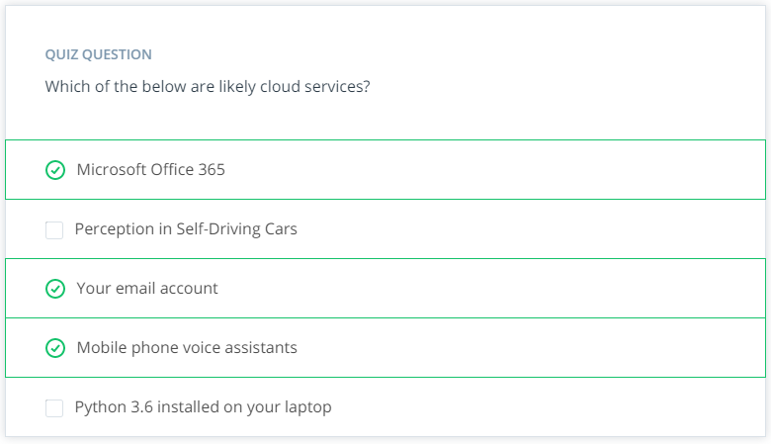**

# Why Cloud Development Is Important

You've probably worked with various cloud services before, such as Microsoft OneDrive and Google Docs, and of course, you'll be working with Microsoft Azure in this course.

Some of the advantages of cloud computing are:

* Cost: The cloud provider handles all the upfront costs associated with buying hardware, along with on-going maintenance costs
* Scale: Most are pay-as-you-go depending on demand (elasticity), and can be expanded as needed
* Reliability: Management of backups, disaster recovery, etc. is made easier
* Security: Policies and controls are already in place to protect your data

Some of the disadvantages of cloud computing are:

* It is internet-based, so it can be prone to outages and fluctuations in speed
* Sensitive, private and core data is physically located on someone else's server
* Cloud services will be tailored and customized for your specific cloud instance, potentially making it hard to quickly change providers

**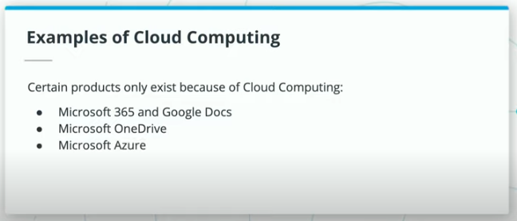**

**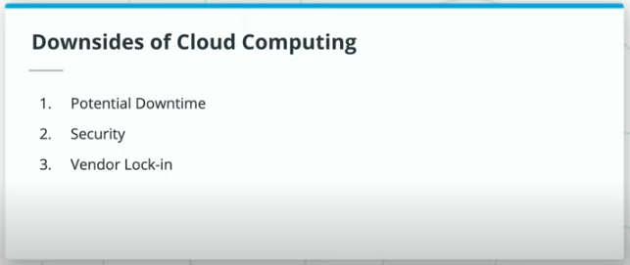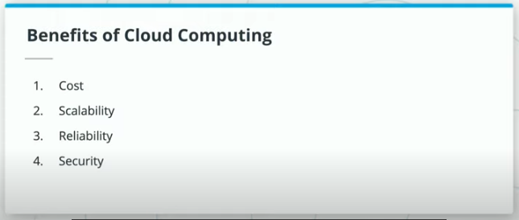**

You've probably worked with various cloud services before, such as Microsoft OneDrive and Google Docs, and of course, you'll be working with Microsoft Azure in this course.

Some of the advantages of cloud computing are:

* Cost: The cloud provider handles all the upfront costs associated with buying hardware, along with on-going maintenance costs
* Scale: Most are pay-as-you-go depending on demand (elasticity), and can be expanded as needed
* Reliability: Management of backups, disaster recovery, etc. is made easier
* Security: Policies and controls are already in place to protect your data

Some of the disadvantages of cloud computing are:

* It is internet-based, so it can be prone to outages and fluctuations in speed
* Sensitive, private and core data is physically located on someone else's server
* Cloud services will be tailored and customized for your specific cloud instance, potentially making it hard to quickly change providers

**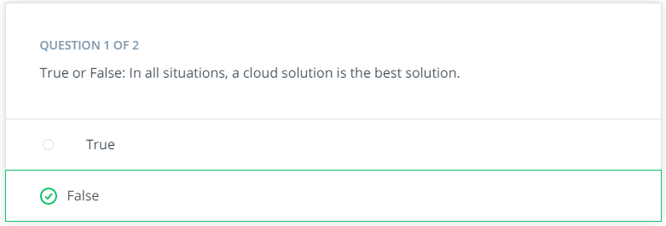**

**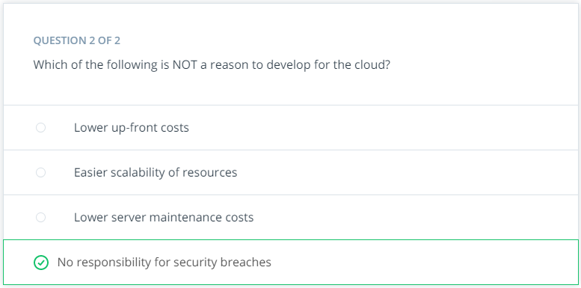**

**Business Stakeholders**

As a cloud developer, you will interact and engage with numerous stakeholders, each of whom has different priorities. Some of these are:

* Your users
* Company executives
* I.T. Department
* Cloud Service provider
* Finance Department

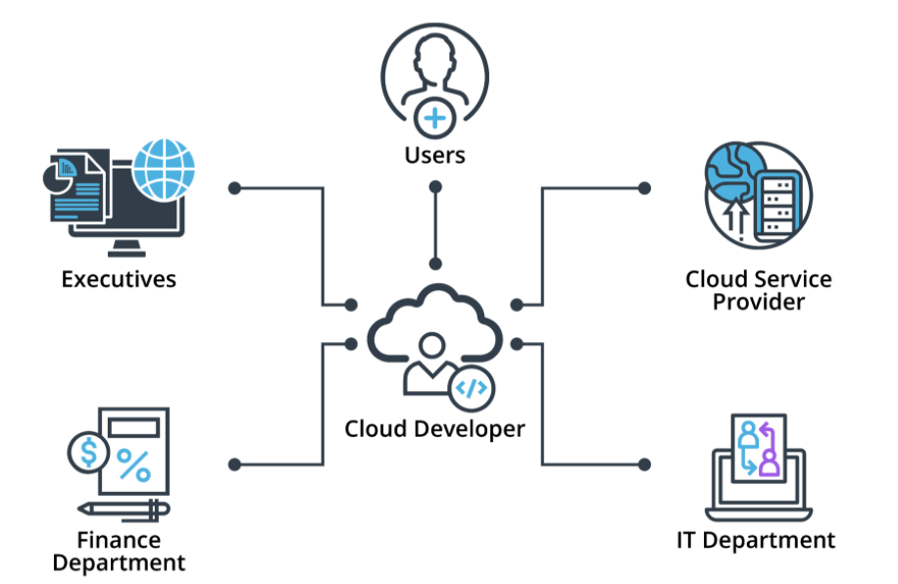

The key stakeholders in cloud development

**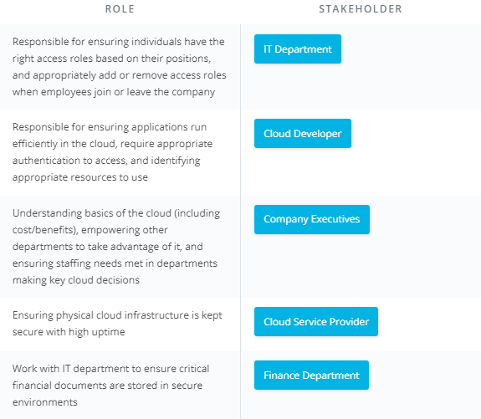**

# History of Cloud Development

## History of Cloud Development

The roots of cloud computing go as far back as the 1960s.

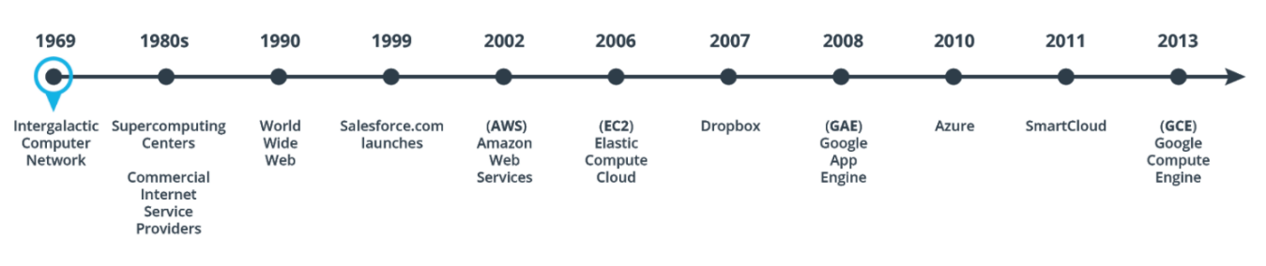

The timeline of cloud development

1969 - JCR Licklider aimed to create a system where information could be accessed anywhere in the world called the “Intergalactic Computer Network”.

1980s - Supercomputing Centers start to form and Commercial Internet Service Providers start to emerge in the late 1980s.

1990 - The internet becomes visible to all when Tim Berners-Lee invents the World Wide Web.

1999 - Salesforce.com launches and becomes a pioneer in delivering enterprise applications over the internet, which is known as Software-as-a-Service(SaaS). This paves the way for other SaaS applications such as Microsoft 365 and Gmail.

2002 - Amazon launches its Amazon Web Services (AWS) platform. AWS is formally launched as a business unit in 2006.

2006 - Amazon launches its Elastic Compute Cloud (EC2), a commercial web service that allowed users to rent computers to run their applications. EC2 paved the way for application delivery over the internet, which allowed web-scaled businesses like Netflix and Spotify to exist.

2007 - Dropbox introduces its file hosting service, and with that cloud storage becomes a commodity.

2008 - Google launches its Google App Engine (GAE) Platform-as-a-Service (PaaS). This service allowed developers to host their web applications on Google’s managed data centers.

2010 - Microsoft launches its cloud computing platform, Azure, after announcing it back in 2008. Azure now covers Software-as-a-Service(SaaS), Platform-as-a-Service(PaaS), and Infrastructure-as-a-Service(IaaS).

2011 - IBM launches SmartCloud, a suite of enterprise-class cloud computing technologies for building private, public, and hybrid clouds.

2013 - Google launches Google Compute Engine (GCE) as an addition to its Google Compute Platform. This is an Infrastructure-as-a-Service (IaaS) component of the platform that allows a user to spin up Virtual Machines (VMs) on demand.

So what’s next? Cloud computing is on the rise in this day and age. As cloud computing continues to become more mainstream, more and more companies are looking to adopt it. Industries such as marketing, education, and healthcare are beginning to increase their use of cloud-based services and platforms.

# Microsoft Azure

**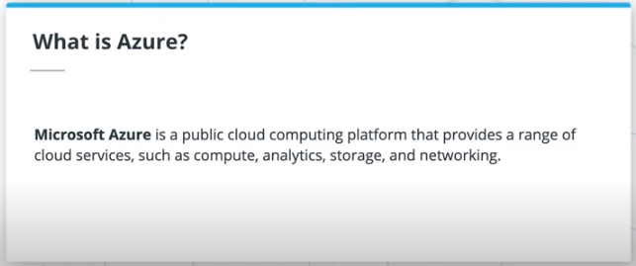**

**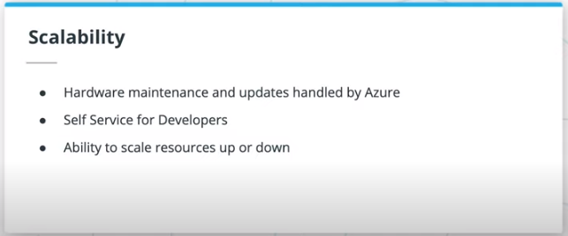**

**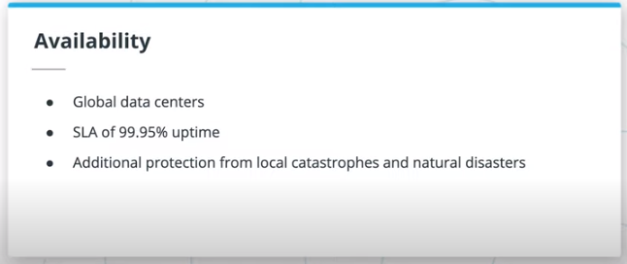**

**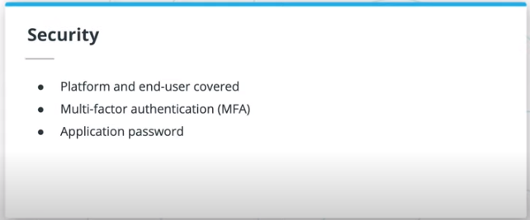**

**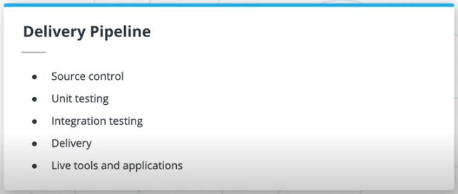**

**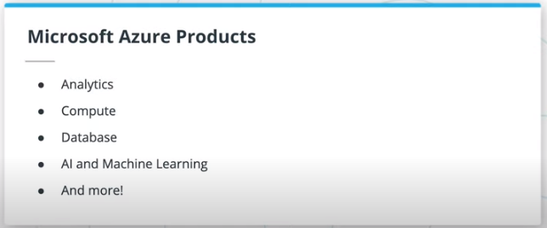**

**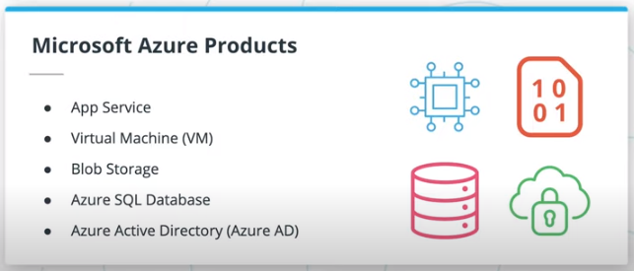**

Azure is a public computing platform with tremendous value and benefits:

* Scalability: can dynamically handle changes in volume, bandwidth, storage size
* Availability: redundant on a global scale with 99.9%+ uptime (see SLA by service [here](https://azure.microsoft.com/en-us/support/legal/sla/summary/" \t "_blank))
* Security: replicated data helps protect against natural disaster, while authentication strategies help secure access to the data
* Standard delivery pipeline development services, such as:
  + Source control
  + Unit testing
  + Integration testing
  + Delivery
  + Live development tools

Azure products span multiple categories, such as Compute, Analytics, Databases, A.I. and Machine Learning.

The Azure products this course will focus on are:

1. App Services
2. Virtual Machines
3. Azure SQL Databases
4. Blob Storage
5. Azure Active Directory
6. Aspects of Azure Monitor, such as logs and alerts

**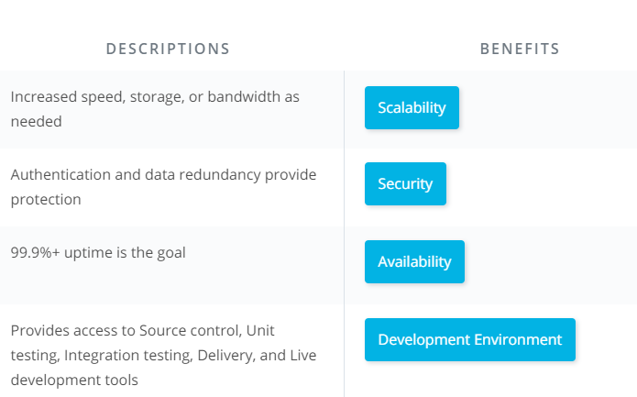**

# The Azure Portal

**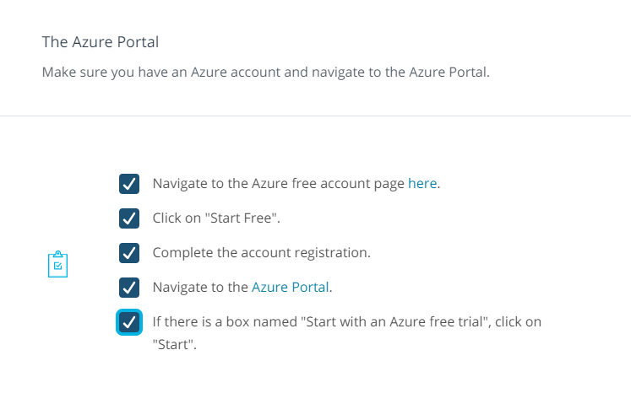**

# IaaS, PaaS, and SaaS

In contrast to on-premises solutions, there are three types of services that Azure offers us:

* Infrastructure as a Service (IaaS) - removes the expense of up-front costs of hardware, software and test environments
* Platform as a Service (PaaS) - handles networking, provides middleware and development & database tools
* Software as a Service (SaaS) - provides end-users access to online cloud solutions

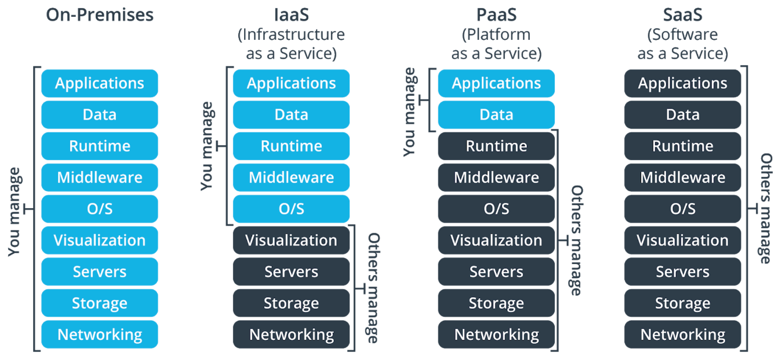

Azure services organized by IaaS, PaaS and SaaS

**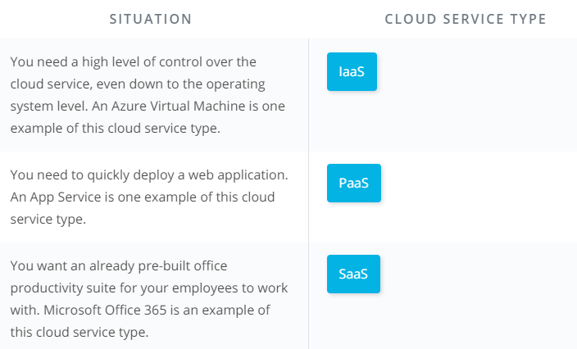**

# Tools & Environment

**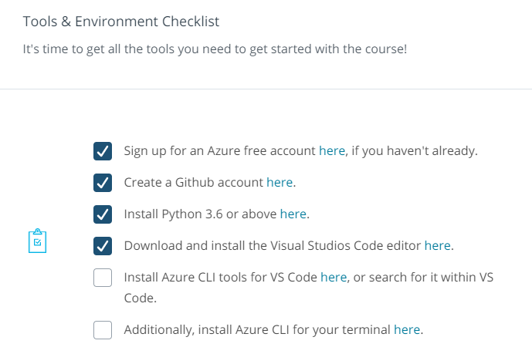**

# Project: Deploy an Article CMS to Azure

It is exciting to take a look at what we will be creating in our **final course project**. Similar to many such systems that exist in the real world, we will be designing, building, and deploying an Article Content Management System (CMS), which will include the ability to :

* Login and authenticate
* Read posts
* Create and save a post
* Edit and save an existing post

The project looks straightforward from the user interface, but there is a lot going on under the hood of this Flask app. The Sign In page makes use of the Microsoft Authentication Library (MSAL) and Azure Active Directory to log in with a Microsoft account, while data related to article titles, authors and text bodies is stored in an Azure SQL Server. An Azure Storage Account with Blob Storage is used to store the images, and the web app itself can be deployed using either an Azure Virtual Machine or an Azure App Service. All of these resources are likely tied to a single resource group.

All these terms may not make much sense to you yet, but by the end of the course, you'll know each resource involved quite well, and be able to deploy your own Article CMS with Azure!

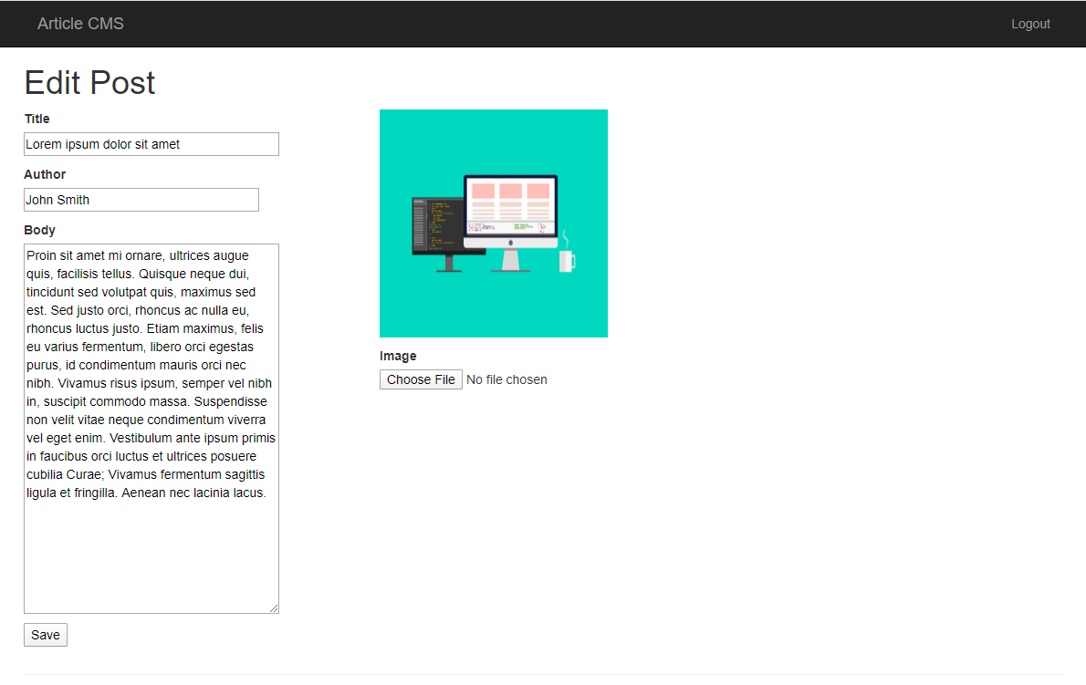

An example article within the deployed CMS

# Lesson Recap

What did we learn in this introductory lesson on Azure Cloud Development?

* Why cloud computing is important, when to use it, and who are the key stakeholders
* History of *the cloud*
* Microsoft Azure and Azure Portal
* Comparing cloud service types - IaaS, PaaS and SaaS
* Tools and environment set up for the course
* The final course project

# Good Luck!

Chris will be with you for the entire course's journey! Good luck and see you in the next lesson!

# Glossary

| **Key Term** | **Definition** |
| --- | --- |
| The Cloud | A collection of servers on the internet that store and manage data, run apps, and deliver content such as email or videos. |
| Cloud Computing | The delivery of software and storage over the Internet (i.e. the cloud). |
| Public Cloud | Cloud computing resources shared amongst multiple customers, with applications and data still separate. |
| Private Cloud | Cloud computing resources that are dedicated to only one entity. This is most similar to how on-premises resources operate, but with the resources still hosted off-site by a third party. |
| Hybrid Cloud | Utilizing a mix of public and private cloud resources. |
| Cloud Developer | Developers who build cloud applications or utilize other cloud resources in their applications. They are responsible for ensuring applications run efficiently in the cloud, requiring appropriate authentication to access, and identifying appropriate resources to use. |
| Microsoft Azure | A public computing platform provided by Microsoft, with many products spanning many categories, such as Compute, Analytics, Databases, A.I. and Machine Learning. |
| Azure Portal | The browser-based and GUI version of working with Azure resources. |
| Elasticity | The ability to scale up or down resources to match demand. |
| On-Premises | The non-cloud option where companies host all their necessary compute, storage and other resources on-site. |
| Infrastructure as a Service (Iaas) | Removes the expense of up-front costs of hardware, software and test environments, as the cloud provider is instead responsible for providing physical hardware. |
| Platform as a Service (Paas) | Handles networking, provides middleware and development & database tools, in addition to the physical hardware provided at the IaaS level. |
| Software as a Service (Saas) | Provides end-users access to online cloud solutions, without the need to build or support the underlying applications themselves. |

**LESSON 2 Azure Compute Services**

**Introduction**

In this lesson, we'll focus on Azure Compute Services:

* First, we'll take a look at some of the various compute options available
* Then, we'll get you set up for success by discussing subscriptions and resource groups
* From there, we'll take a deeper dive into two compute services in Azure: Virtual Machines and App Services
* After comparing and contrasting these two, you'll create both resources and deploy an app to them

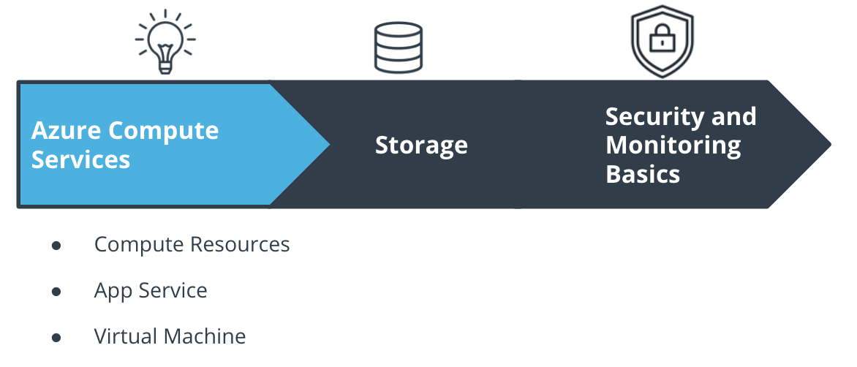

The Course and Lesson Outline

**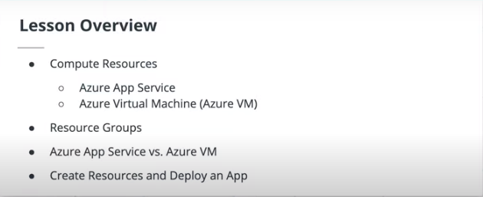**

**Big Picture: Compute Services**

**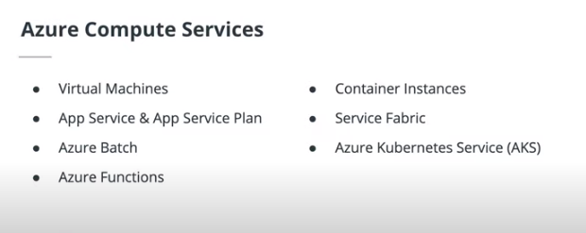**

There are a lot of compute services available through Azure, each with their own use cases. You can check out a good chart for deciding when to use each (which you'll see more of in later lessons and courses) in the [Microsoft documentation](https://docs.microsoft.com/azure/architecture/guide/technology-choices/compute-decision-tree?WT.mc_id=udacity_learn-wwl" \t "_blank). Some of the available options are:

* Virtual Machines
* App Services
* Azure Batch
* Azure Functions
* Container Instances
* Service Fabric
* Azure Kubernetes Service (AKS)

We'll focus on Virtual Machines and App Services in this lesson, although you'll see some of the others in a later course.

**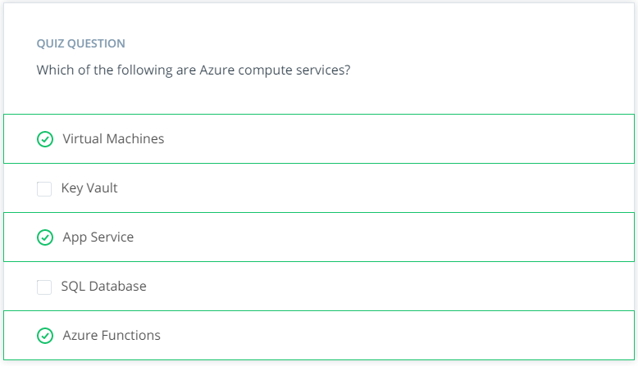**

**Subscriptions and Resource Groups**

**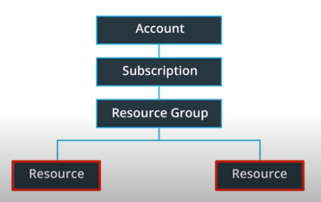**

**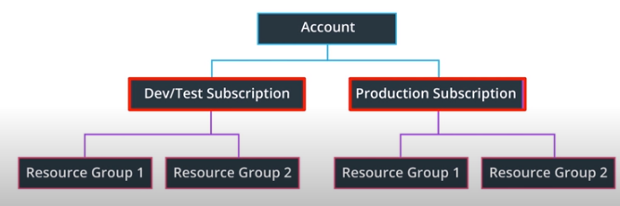**

**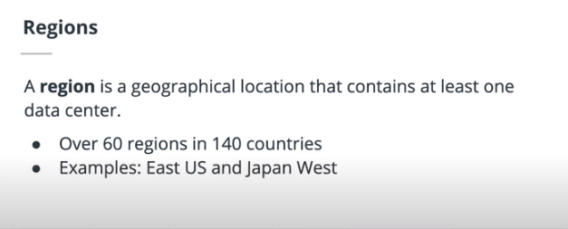**

**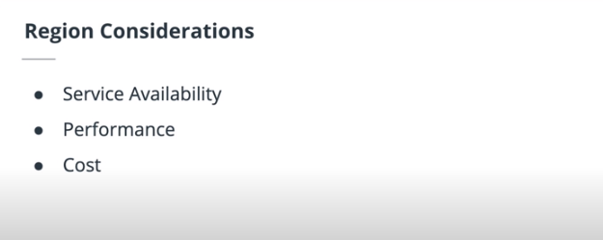**

Azure uses a hierarchical system to keep resources organized and to manage expenses easily.

This starts at the top with your **Azure Account**. The next level down is the **Subscription** level; in this course you will likely only work with one subscription, but it's likely in your day-to-day Azure work that you may be working with more than one. For instance, there may be one subscription for development and testing, and another for production systems.

Below the subscription level is where you'll find **Resource Groups**. These help to organize resources you use, such as Virtual Machines and App Services (as well as storage options and other resources we'll discuss in later lessons), in order to make resource management easier. You may have a resource group for a specific project, or because resource groups are tied to a **Region**, you may have resource groups containing similar resources in multiple locations across the world. A region contains at least one data center, but could have multiple data centers that are close by and networked together through a low-latency network. There are over 60 regions available worldwide and available in 140 countries, such as East US and Japan West.

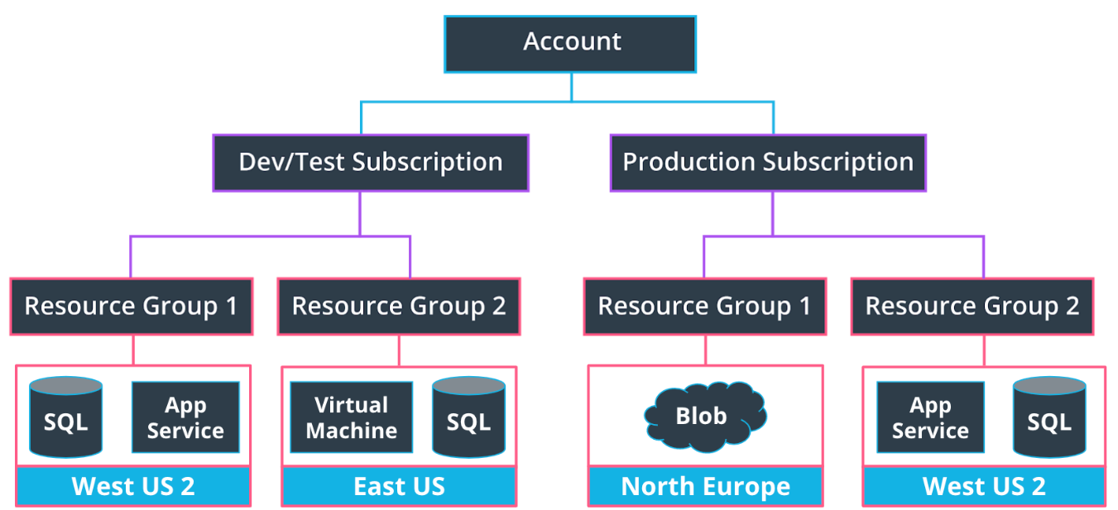

Resource groups can encompass multiple services in a region.

When choosing a region, it's important to consider what you are trying to achieve. For development and testing purposes, you likely want a region close to yourself; for production purposes, you often want resources to be close to your user. Keep the following in mind:

* Service availability - Some services may not be available in a particular region.
* Performance - Latency determines network service performance; are you creating resources for yourself or your end user?
* Cost - Costs of services vary by region. If latency isn’t an issue, you might want to deploy your services in the cheapest region.

### Creating a Resource Group in the Azure Portal

To set up a resource group in the Azure Portal:

* Go to the [Azure Portal homepage](https://portal.azure.com/" \l "home" \t "_blank)
* Click "Create a Resource Group"
* Search for "Resource group" and click "Create"
* You'll need to select the subscription for the resource group, name it, and select a region
* Make sure once you select "Review and create" to actually review the information! While it doesn't take too much time to go back and create a new resource group, you'll want to check for any typos in the name or if the wrong region was selected. When we work out of Azure CLI later, this becomes even more important, as you could cause other scripts to fail if things are named incorrectly or are in an inappropriate region.
* Click "Create" once you are done reviewing.

You'll practice this yourself in the upcoming exercise.

**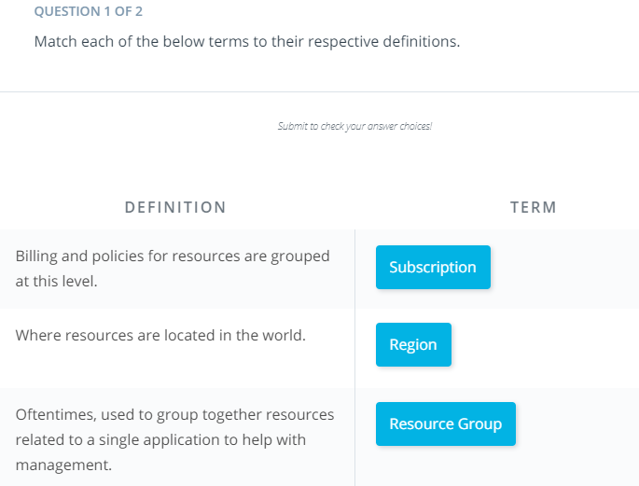**

**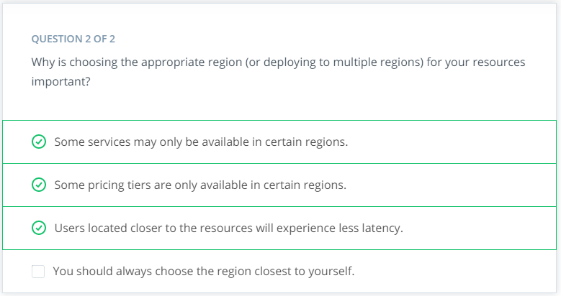**

**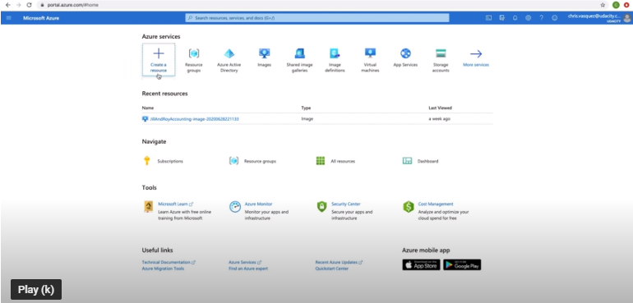**

**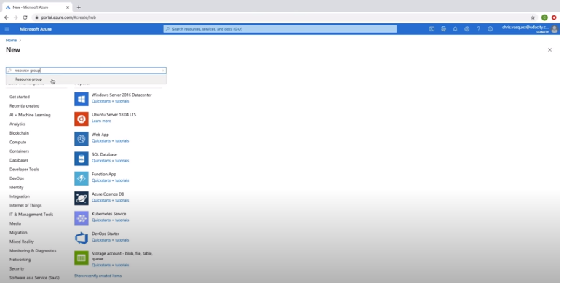**

**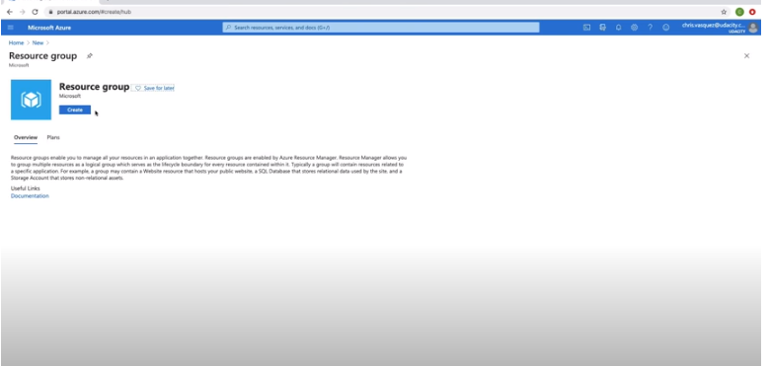**

**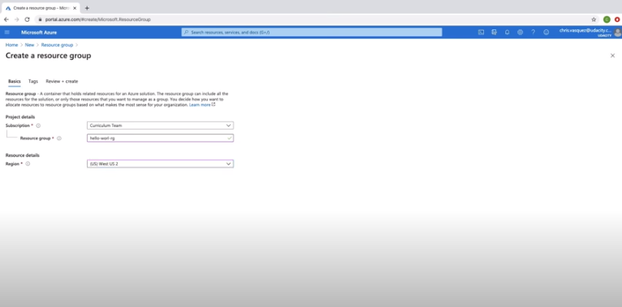**

**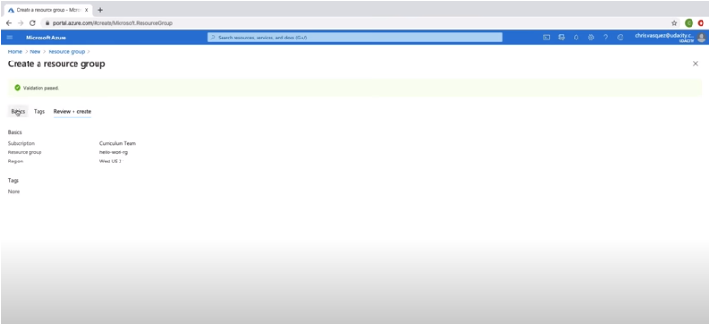**

**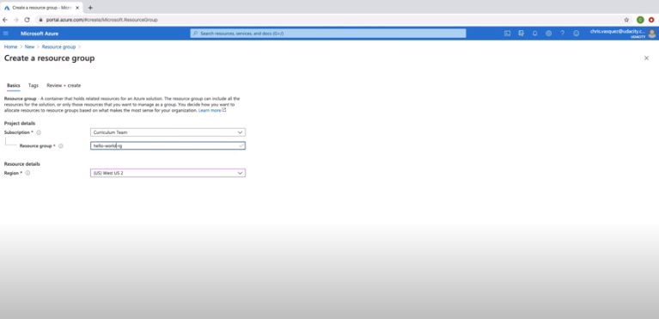**

**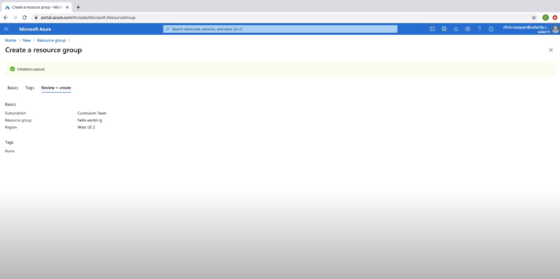**

**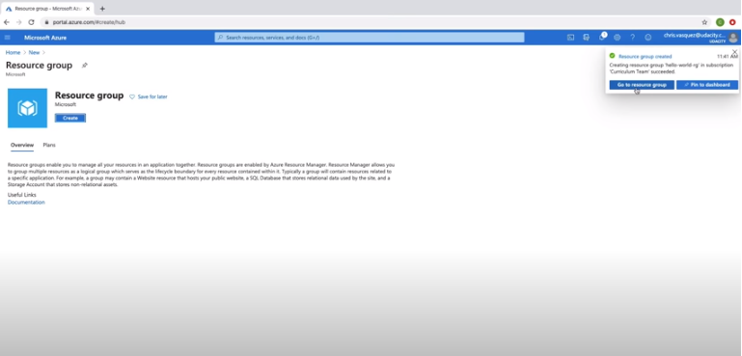**

**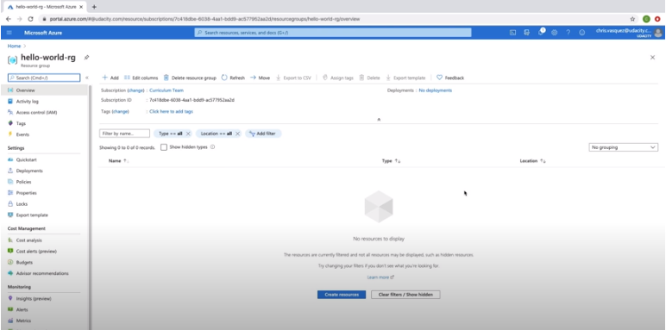**

# Exercise: Create A Resource Group

## Exercise: Create a Resource Group

In this exercise, you'll create a resource group in Azure. This is a quick exercise, but will set you up for success through the rest of the course!

* Create a Resource Group named **resource-group-west** in [Azure](https://www.portal.azure.com/) in the **West US** region.

**Note:** We will use this resource group throughout the course, so do not delete it after creation. Resource Groups are fully covered in the Azure free account.

# Solution: Subscriptions and Resource Groups

In this solution video, I showed you an alternative way to create a resource group using Azure CLI. Use whichever method you feel more comfortable with moving forward.

**Steps to Create a Resource Group using the Azure CLI:**

1. Log in using az login.
2. We'll use the Azure CLI command az group create and pass in two flags:
   * resource group --name
   * --location which is the same as the "region" field on the Azure portal.
3. If you want to see a list of all locations, you can run az account list-locations -o table to output the list in table format.
4. I want to create my resource group in the West US 2 region:

az group create --name resource-group-west --location westus2

The resource group will be created and a JSON response will be returned with the status.

Alternatively, you can check out the screenshot below for how you might do the same from the Portal (note that the below uses the West US region and not West US 2).

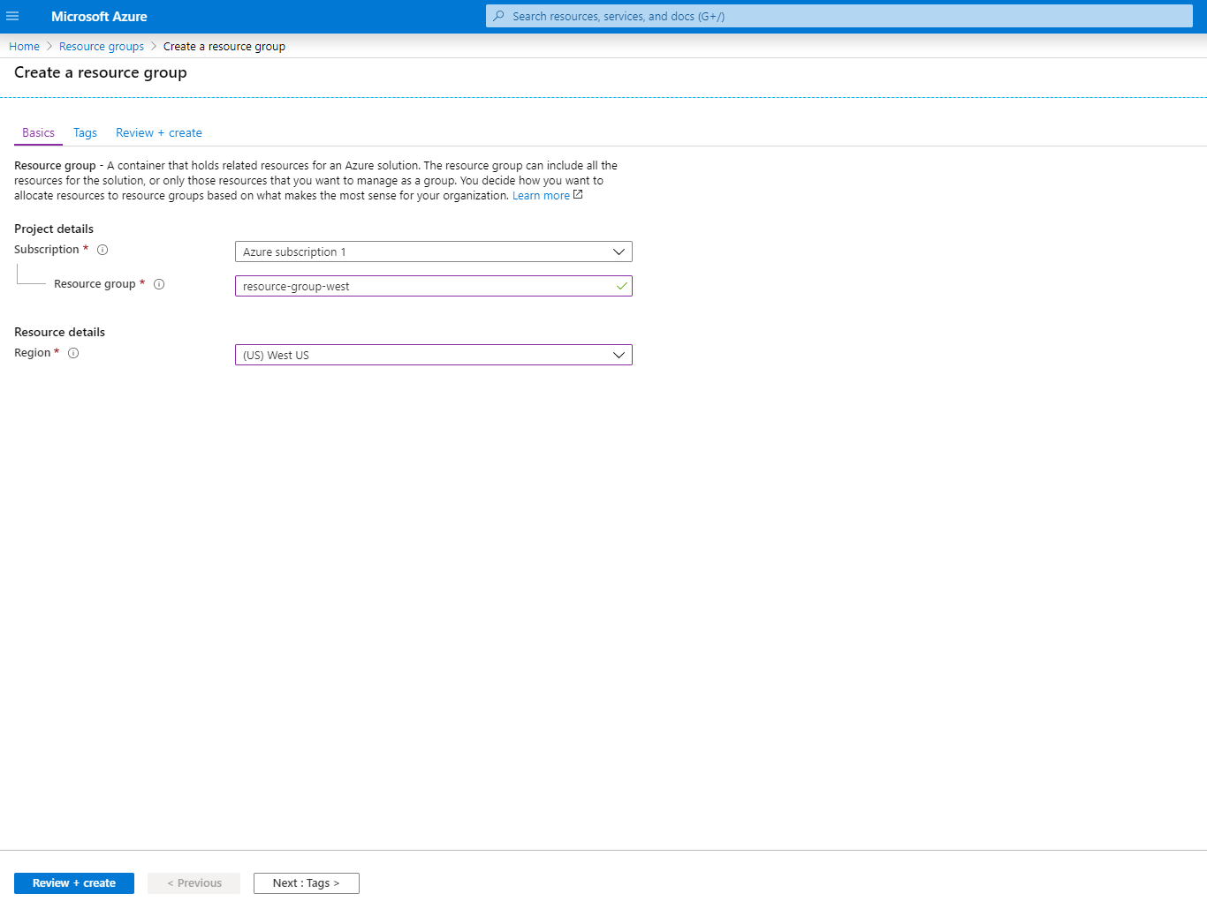

## Azure CLI Documentation

You can reference the [Azure CLI documentation](https://docs.microsoft.com/cli/azure/?view=azure-cli-latest&WT.mc_id=udacity_learn-wwl" \t "_blank) for further information on other commands.

# Virtual Machines vs. App Services

### Virtual Machines

**Azure Virtual Machines** (VMs) provide infrastructure as a service (IaaS) by allowing you to create and use virtual machines in the cloud.

Some of the benefits of VMs are:

* VMs allow you full access and control of the VM.
* Lower up-front cost compared to purchasing and maintaining hardware.
* Support of both Linux and Windows VMs.
* Multiple types to choose from, such as compute or memory-optimized VMs, along with varying amounts of CPU, RAM and storage.
* VMs allow for the installation of custom images and are an excellent choice for migrating from an on-premises server to the cloud.
* Multiple VMs can be grouped to provide high availability, scalability, and redundancy. There are two options when it comes to scaling—Virtual Machine Scale Sets and Load Balancers. These will be covered in a different course.

Some of the limitations of VMs are:

* They are more expensive
* They can be more time consuming for the developer than other compute options

### App Service

**Azure App Service** is an HTTP-based service for hosting web applications, REST APIs, and mobile back ends. It is a Platform as a Service (PaaS) that allows a developer to focus on the application while Azure takes care of the infrastructure.

Some of the benefits of using an App Service are:

* Support of multiple languages, such as .NET, .NET Core, Java, Ruby, Node.js, PHP, or Python
* High availability, auto-scaling and support of both Linux and Windows environments.
* Continuous deployment model using GitHub, Azure DevOps, or any Git repo.
* Vertical or Horizontal scaling. Vertical scaling increases or decreases resources allocated to our App Service, such as the amount of vCPUs or RAM, by changing the App Service pricing tier. Horizontal scaling increases or decreases the number of Virtual Machine instances our App Service is running.
* You can set the amount of hardware allocated to host your application, and cost varies based on the plan you choose. There are three different tiers - Dev/Test, Production, and Isolated. We’ll be using the free option within Dev/Test for the exercises in this course.

Some of the limitations of an App Service are:

* You have limited access to the host server, so you are unable to control the underlying OS or install software on the server.
* You’re always paying for the service plan, even if your services or application isn’t running.
* There are hardware limitations, such as a maximum of 14GB of memory and 4 vCPU cores per instance
* While they support multiple languages, as noted in the benefits above, they are limited to just using those languages (as of when this course was built).

### Use Cases

Each of these has their own use cases, although sometimes there is still some ambiguity on when to use each. Virtual Machines are usually better when you need control of the underlying operating system or are using custom software to support your needs; an app service is typically better for lightweight applications and services, especially when you don't have the need for high performance compute services. Additionally, you'll need to take into consideration the hardware limitations of App Services, as noted above.

**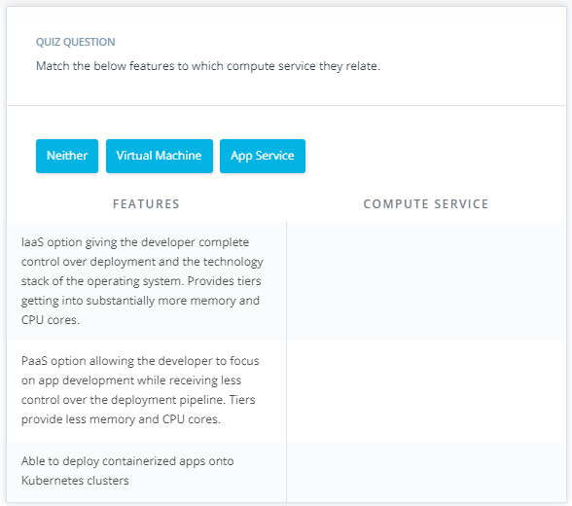**

**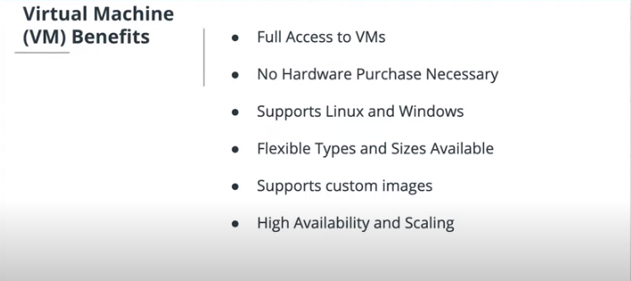**

**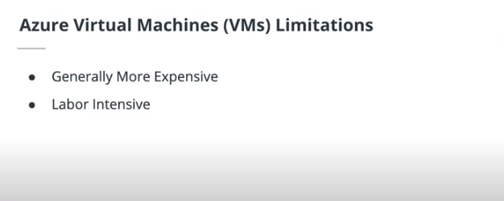**

**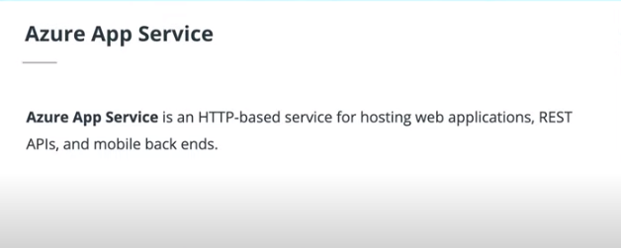**

**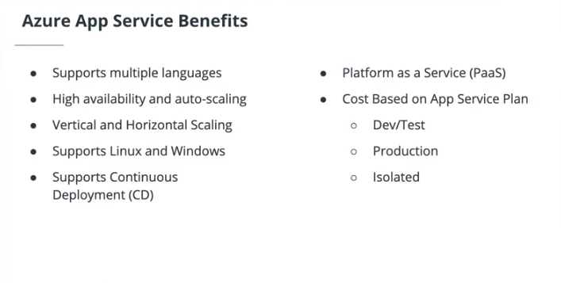**

**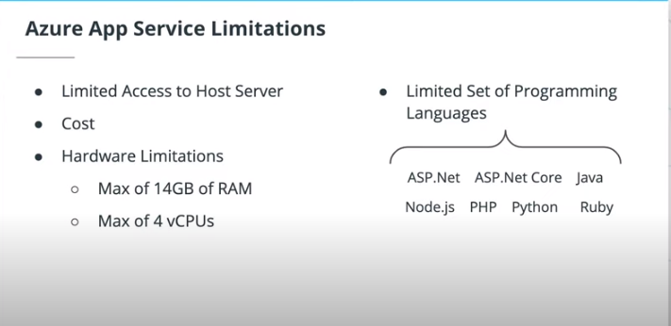**

**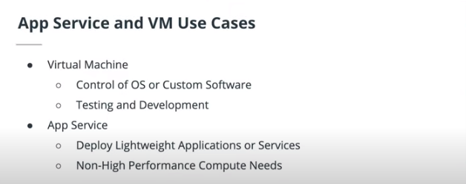**

# Exercise: Virtual Machines vs. App Services

## Virtual Machines vs. App Services

For each of the three scenarios below, analyze and determine whether a virtual machine or an app service would be best served for the situation. It's important to note that this involves some level of ambiguity - you should feel free to expand beyond the given scenario and consider any other areas that might be important in making your decision.

### Scenario 1

*Your company wants to deploy a series of lightweight APIs as part of their plan to shift to using microservices in the future. The company is very cost-conscious due to the current economic environment, and wants to focus on using the correct services right now, and is less concerned about scaling concerns due to stagnant growth.*

## Scenario 1 Scratchpad

You can use this space as a scratchpad of your thoughts on Scenario 1. Note that this will lock after you submit it.

### Your reflection

**App Services**

### Things to think about

Thanks for your response! You can continue onto the next scenario for now, I'll cover my own approach on the next page.

### Scenario 2

*Your company has recently signed a sizable government contract in which you will deploy various apps for the related government departments to use. The contract was a big win for the company, as it vastly increases the number of users of your apps. Additionally, the contract does contain provisions that require dedicated servers for security reasons to host any of the government department's services and information. Relatedly, some of the different departments' applications are required to be maintained on different servers.*

## Scenario 2 Scratchpad

You can use this space as a scratchpad of your thoughts on Scenario 2. Note that this will lock after you submit it.

### Your reflection

**Virtual Machines**

### Things to think about

Thanks for your response! You can continue onto the next scenario for now, I'll cover my own approach on the next page.

### Scenario 3

*You have been assigned to determine the cloud needs for a new product your company will soon be launching. In the past couple of years, your company has been on a roller coaster ride - some product launches meet massive success, while others flounder pretty quickly out of the gates. As such, the product manager is a bit wary of immediately creating a bunch of resources without knowing for sure what the real demand for this new product will be. The application currently utilizes ~5 GB on 2 CPUs during your stress testing, but is definitely a minimum viable product, and could grow vastly in size and compute resources if successful.*

## Scenario 3 Scratchpad

You can use this space as a scratchpad of your thoughts on Scenario 3. Note that this will lock after you submit it.

### Your reflection

**App Services**

### Things to think about

Thanks for your response! I'll cover my own approach on the next page.

# Solution: Virtual Machines vs. App Services

### Scenario 1

*Your company wants to deploy a series of lightweight APIs as part of their plan to shift to using microservices in the future. The company is very cost-conscious due to the current economic environment, and wants to focus on using the correct services right now, and is less concerned about scaling concerns due to stagnant growth.*

Some key points that stood out to me were:

* Deploying a series of lightweight APIs
* Less concern about scaling up processing power
* Cost-consciousness

I would choose an **App Service** in this situation. Lightweight APIs tend to be well-suited to App Services over VMs, and won't approach the size limit for App Services very easily. Additionally, App Services cost less than VMs do. Lastly, since the ability to scale quickly is less of a concern, we don't need to factor that into the analysis.

As the company shifts into microservices, Azure Functions would also be a good compute option for them to consider, but that won’t be covered until a later course.

### Scenario 2

*Your company has recently signed a sizeable government contract in which you will deploy various apps for the related government departments to use. The contract was a big win for the company, as it vastly increases the number of users of your apps. Additionally, the contract does contain provisions that require dedicated servers for security reasons to host any of the government department's services and information. Relatedly, some of the different departments' applications are required to be maintained on different servers.*

A couple of key points that stood out to me were:

* A vast increase in the number of users
* The need for dedicated servers for security reasons

This situation is likely best for **Virtual Machines**. Handling the vast increase in the number of users, with separate, dedicated servers, is going to be better achieved this way.

### Scenario 3

*You have been assigned to determine the cloud needs for a new product your company will soon be launching. In the past couple of years, your company has been on a roller coaster ride - some product launches meet massive success, while others flounder pretty quickly out of the gates. As such, the product manager is a bit wary of immediately creating a bunch of resources without knowing for sure what the real demand for this new product will be. The application currently utilizes ~5 GB on 2 CPUs during your stress testing, but is definitely a minimum viable product, and could grow vastly in size and compute resources if successful.*

This is a bit of a tough one - it's important to remember that in real-life situations, there may not always be a clear dividing line on exactly which service is best.

Some key points that stood out to me were:

* The confidence level of this application being a massive success seems low (do we want to assume we'll need a lot of scaling?)
* The application currently utilizes ~5 GB on 2 CPUs during stress testing
* The potential the app will grow in resource needs

The answer here depends greatly on which of the above points you highlight. In the current situation, an App Service likely works fine - it can scale vertically to meet different demand levels, and the compute resources needed are well within App Service limits. However, there's some consideration that Virtual Machines may be necessary in the near future if many more features are added, or demand changes in a way that requires vertical scaling. In fact, I'd argue that the problem so far is a bit ill-defined - I'd want to know what level of control we need over the underlying OS, security requirements we have, etc.

**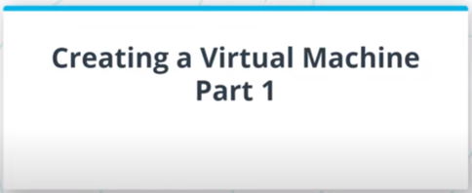**

**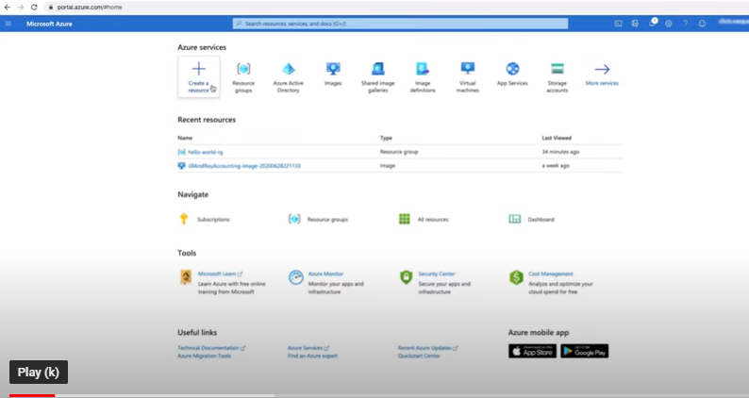**

**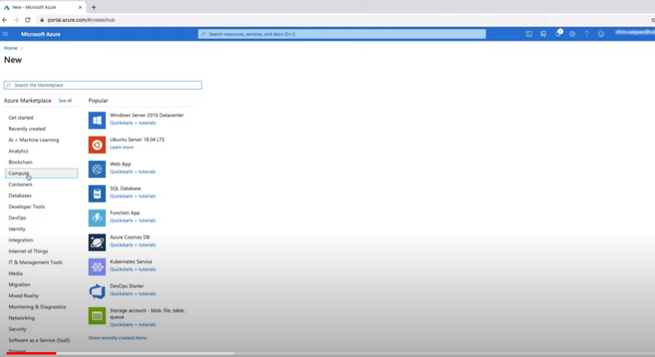**

**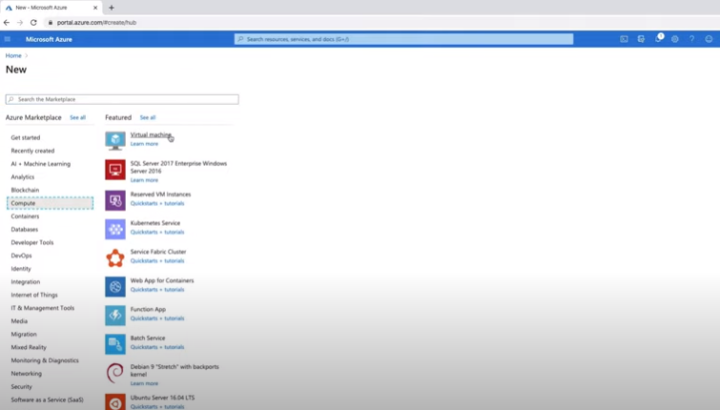**

**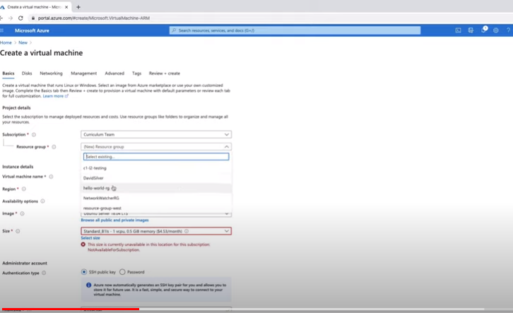**

**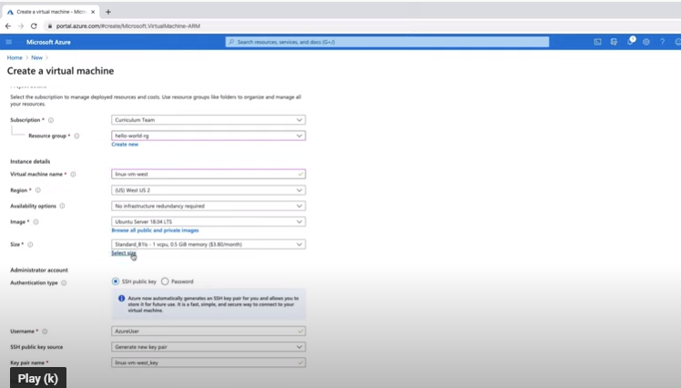**

**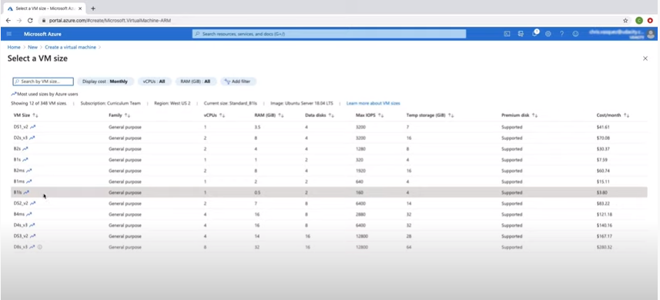**

**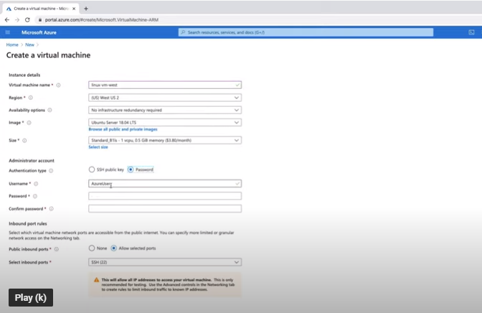**

**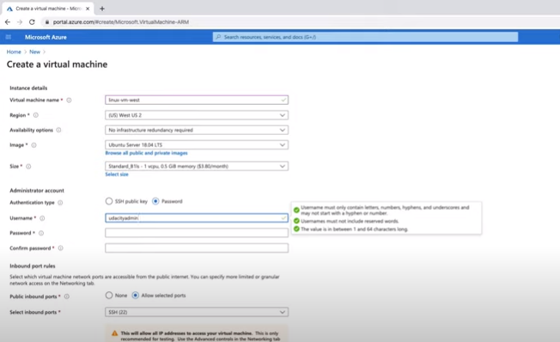**

**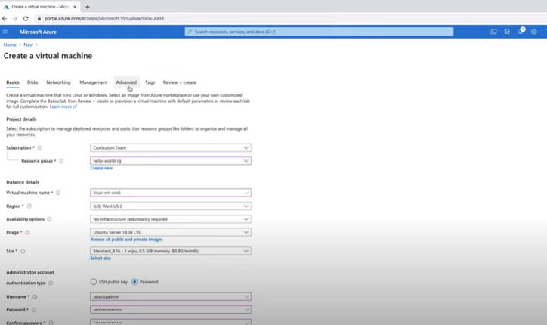**

**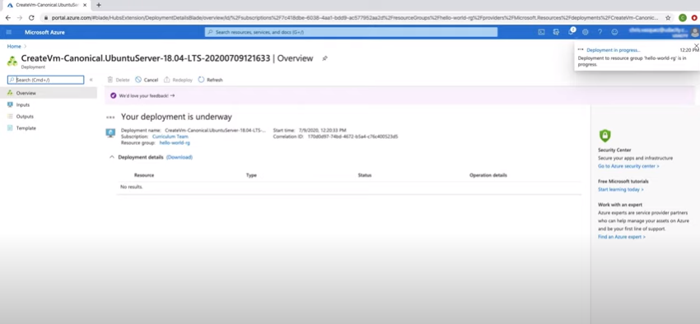**

**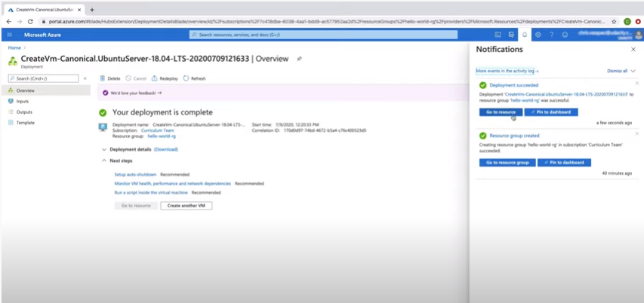**

**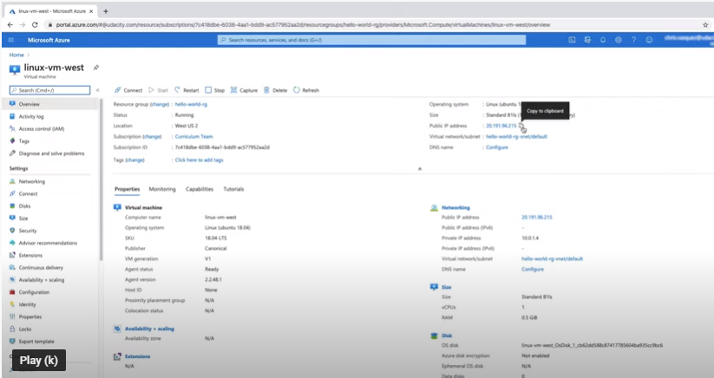**

The steps I took to create a Linux Virtual Machine on Azure were:

1. On the homepage, click "Create a resource"
2. Click on "Compute" in the left menu
3. Click on "Virtual Machine"
4. Create a Linux VM with the following details:
   * Subscription: This will vary for you. Should default to your subscription.
   * Resource Group: "hello-world-rg"
   * VM Name: "linux-vm-west"
   * Region: West US 2 or a region closest to you that's available
   * Availability Options: Default option of "No infrastructure redundancy required" is fine here.
   * Image: Ubuntu Server (any version) but I'm going to use the latest version 18.04 LTS
   * Azure Spot instance: No
   * Size: Click on "Select Size" and select "Standard B1ls"
   * Authentication type: Password
   * Username: (any username you choose) something other than the default "AzureUser" I used "udacityadmin"
   * Password: (any password you choose) "Udacityadmin@123"
   * Inbound Port Rules: "Allow Select Ports" and make sure from the drop-down menu, 22 and 80 are selected.

**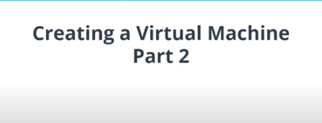**

**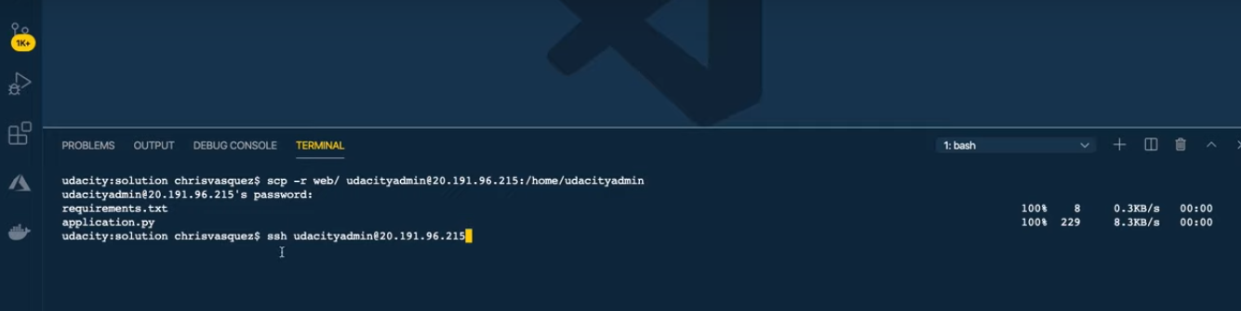**

**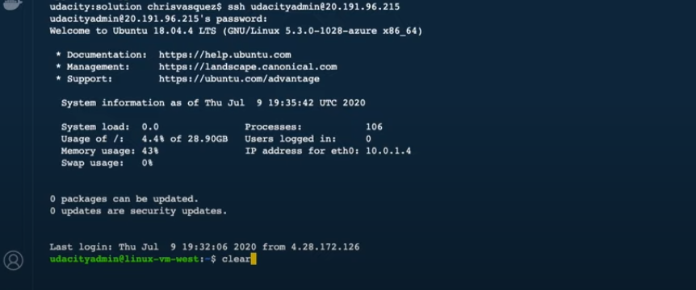**

**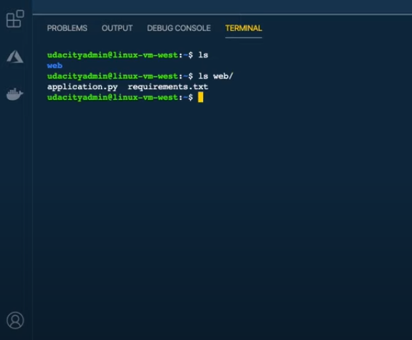**

**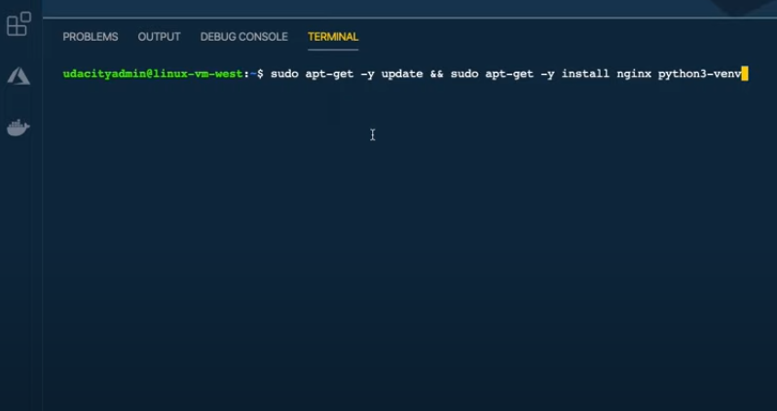**

**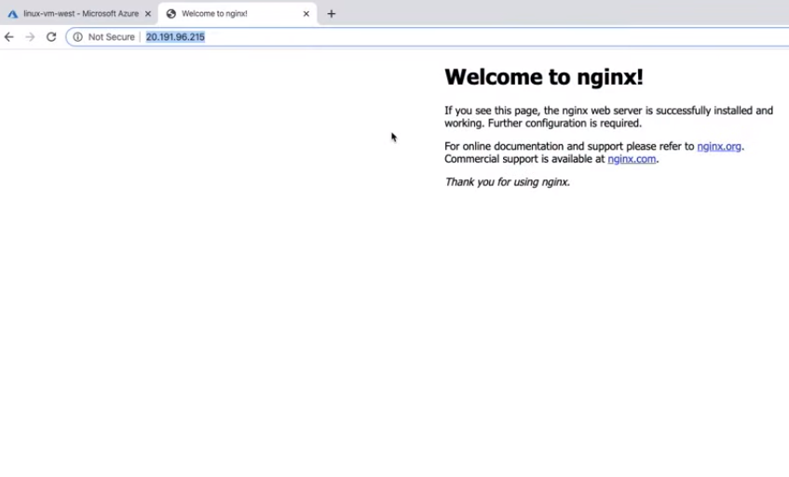**

**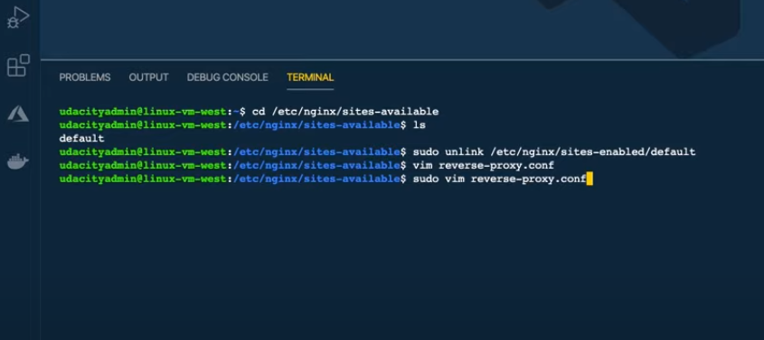**

**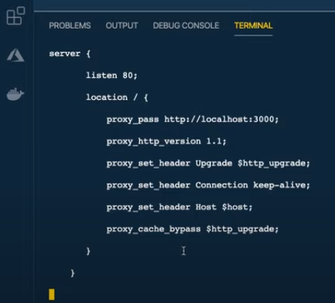**

**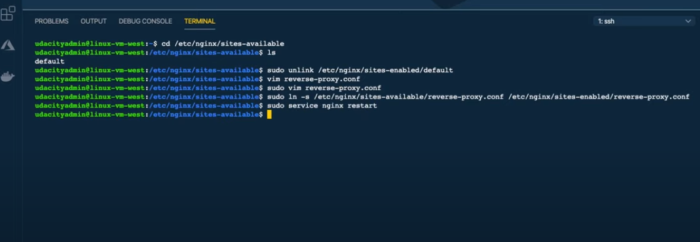**

**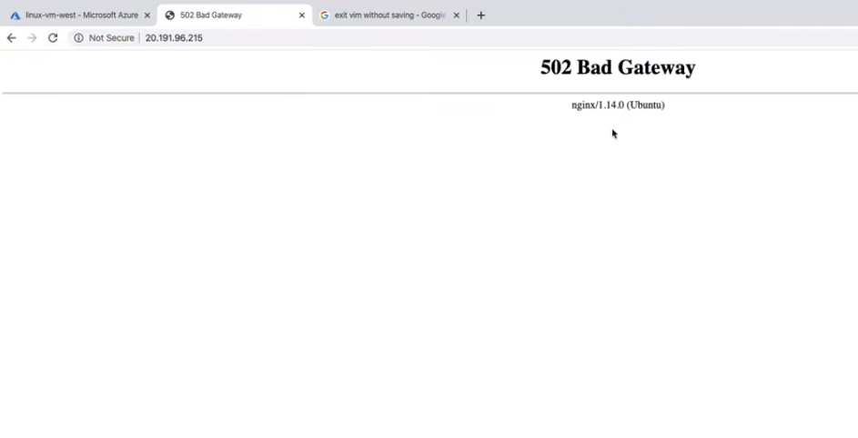**

**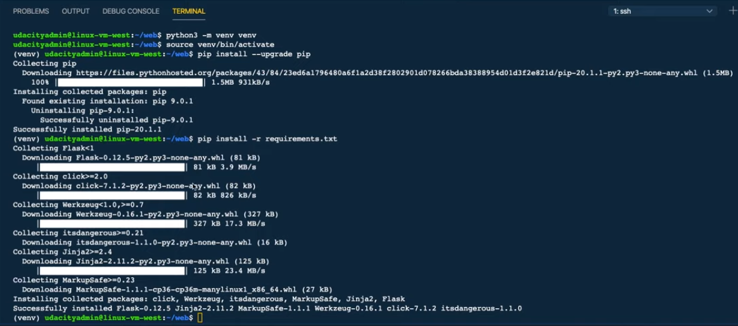**

**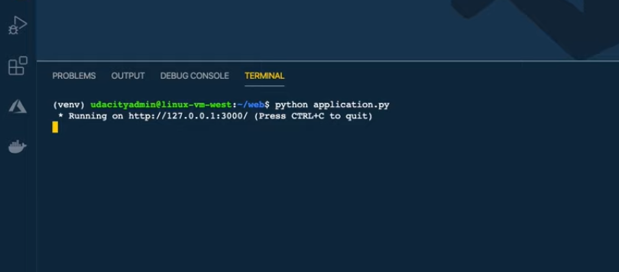**

**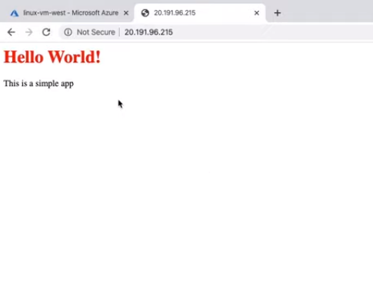**

To connect to the created VM, I did the following (note that Windows users should use PowerShell or Bash):

1. We'll need our admin username we set when creating the VM - "udacityadmin"
2. We'll need the public IP address of our VM. You can use the following command to grab the IPs addresses for a particular VM from the CLI— az vm list-ip-addresses -g <RESOURCE-GROUP> -n <VIRTUAL-MACHINE-NAME> or use Azure portal.
3. Next, we're going to copy a basic Flask app from my local machine to the VM. We'll be using the secure copy utility—scp -r <SOURCE-DIR> [ADMIN-NAME]@[PUBLIC-IP]:<TARGET-DIR>. In this example, I used—scp -r ./web udacityadmin@IPADDRESS:/home/udacityadmin **NOTE**: The first time you try connecting to the VM, you'll see a similar message to the one below and should answer 'yes' to permanently add the IP address to the list of known hosts.

*The authenticity of host '52.191.135.139 (52.191.135.139)' can't be established.  
ECDSA key fingerprint is SHA256:7bBVTsYNImhXxAn+xscCHm/OkcodHZS615VSKO3GP8c.  
Are you sure you want to continue connecting (yes/no)?*

1. Once the files have been copied to the VM, we can connect to the VM using—ssh [ADMIN-NAME]@[PUBLIC-IP]
2. We can usels to see the web directory we just uploaded
3. Python 3 is already installed on the VM. We'll install Python Virtual Environment and NGNIX to use as a reverse proxy sudo apt-get -y update && sudo apt-get -y install nginx python3-venv
4. Before we run the app, we have to configure Nginx to redirect all incoming connections on port 80 to our app that is running on localhost port 3000
   * By default, Nginx has a default page that is displayed. If you visit the public IP address in your browser, you should see this page rendered.
   * We'll navigate to the **/etc/nginx/sites-available** directory—cd /etc/nginx/sites-available
   * We’ll first unlink the default site using sudo unlink /etc/nginx/sites-enabled/default
   * Then we’ll create a new file **reverse-proxy.conf** in the **/etc/nginx/sites-available**—sudo vim reverse-proxy.conf
   * We're going to add the following code to this file:
5. **server** {
6. **listen** 80;
7. **location** / {
8. **proxy\_pass** http://localhost:3000;
9. **proxy\_http\_version** 1.1;
10. **proxy\_set\_header** Upgrade $http\_upgrade;
11. **proxy\_set\_header** Connection keep-alive;
12. **proxy\_set\_header** Host $host;
13. **proxy\_cache\_bypass** $http\_upgrade;
14. }
15. }

Now we’ll activate the directories by creating a sym link to the **/sites-enabled** directory sudo ln -s /etc/nginx/sites-available/reverse-proxy.conf /etc/nginx/sites-enabled/reverse-proxy.conf

* + We have to restart nginx so the changes take effect. sudo service nginx restart

1. cd to web
2. Create venv python3 -m venv venv
3. Activate the env source venv/bin/activate
4. Upgrade pip in our virtual environment and then Install dependencies pip install --upgrade pip pip install -r requirements.txt
5. We'll run our app python application.py
6. In a web browser, we can visit the public IP address of the VM and you should see the application
7. Type "exit" to disconnect from the VM

**Note:** Azure free account only allows 750 hours of free hosting. Make sure to delete this VM after creation for any exercises to avoid charges.

### Cleanup

If we no longer need a resource, we can delete them through the portal.

1. From the homepage, click on "Resource Group"
2. Click on the resource group you want to manage
3. You have two options—"Delete resource group" or if you want to keep the resource group, you can click on the individual or collection of resources you want to delete and click on "Delete"

**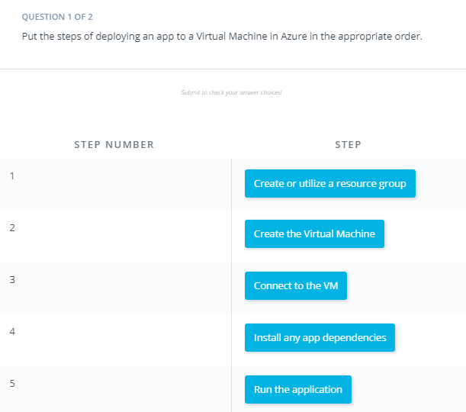**

**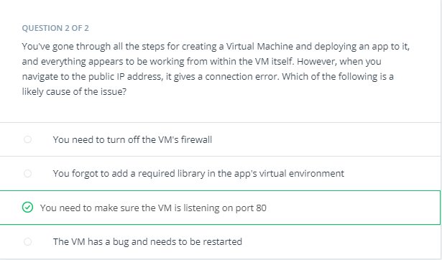**

# Exercise: Creating a Virtual Machine

## Create a Linux Virtual Machine

In this exercise, you'll create and connect to a Linux Virtual Machine in Azure.

**Prerequisite:** If you're using Windows, you’ll need PowerShell or Bash to connect to the VM with ssh. Windows 10 should already have Powershell installed. If you don't have it already installed, [here is a guide](https://docs.microsoft.com/powershell/scripting/install/installing-powershell-core-on-windows?view=powershell-7&WT.mc_id=udacity_learn-wwl" \t "_blank) on how to install it.

1. Create a Linux VM called “linux-vm-west” inside “resource-group-west” which was created in a previous exercise. The VM should have the following configurations:
   * VM Name: "linux-vm-west"
   * Region: West US or the closest region to you that's available
   * Availability Options: No infrastructure redundancy required.
   * Image: Ubuntu Server (any version)
   * Azure Spot instance: No
   * Size: Standard B1ls
   * Authentication type: Password
   * Username: (any username you choose)
   * Password: (any password you choose)
   * Inbound Port Rules: Allow both 22 and 80
2. After creating the VM, use **secure copy** to copy the web directory from [here](https://video.udacity-data.com/topher/2020/July/5f1875e2_create-vm-starter/create-vm-starter.zip" \t "_blank) to the VM. scp -r ./web <USERNAME>@<IPADDRESS>:/home/<USERNAME>
3. After copying the files to the VM, **connect** to it and run the command ls to check the web directory is on the VM.
4. Next, install python3-env and nginx sudo apt-get -y update && sudo apt-get -y install nginx python3-venv
5. Next, configure nginx to listen for incoming traffic on port 80 and set port 3000 as the proxy.
   * Navigate to /etc/nginx/sites-avaiable
   * Remove the default file
   * Replace it with a file containing:
   * **server** {
   * **listen** 80;
   * **location** / {
   * **proxy\_pass** http://localhost:3000;
   * **proxy\_http\_version** 1.1;
   * **proxy\_set\_header** Upgrade $http\_upgrade;
   * **proxy\_set\_header** Connection keep-alive;
   * **proxy\_set\_header** Host $host;
   * **proxy\_cache\_bypass** $http\_upgrade;
   * }
   * }
   * After saving the file, restart nginx sudo service nginx restart
6. Change to the web directory and create and activate a virtual env
7. As a best practice, update pip in a newly created virtual env
8. Install dependencies from **requirements.txt**
9. Run the application and visit the public IP address in your browser. You should see the application running if done correctly.

### Cleanup

Once you're done with the exercise, be sure to delete the VM and it's resources to avoid incurring unwanted charges.

**Note:** Azure free accounts only allow 750 hours of free hosting. Make sure to delete this VM after completing the exercise to avoid charges.

#### **Supporting Materials**

[**create-vm-starter.zip**](https://video.udacity-data.com/topher/2020/July/5f1875e2_create-vm-starter/create-vm-starter.zip)

# Solution: Creating a Virtual Machine

In this solution video, I showed you an alternative way to create a Linux VM using Azure CLI. Use whichever method you feel more comfortable with moving forward. Connecting to the VM is done the same way in both instances.

1. First, we'll login using az login
2. Next, we'll create our VM using az vm create. If we don't pass a location, it defaults to the location of the resource group. This would be fine in most cases, but it's worth noting that sometimes a VM size might not be available in the same region as your resource group, so you'd have to pass in a location for a different region.

az vm create \

--resource-group "resource-group-west" \

--name "linux-vm-west" \

--location "westus2" \

--image "UbuntuLTS" \

--size "Standard\_B1ls" \

--admin-username "udacityadmin" \

--generate-ssh-keys \

--verbose

1. Upon success, you will have a JSON response.
2. Next we will open port 80 to allow outside traffic to our VM

az vm open-port \

--port "80" \

--resource-group "resource-group-west" \

--name "linux-vm-west"

1. Upon success, you will receive a JSON response.

Alternatively, you can check the screenshot below for the same approach through the portal.

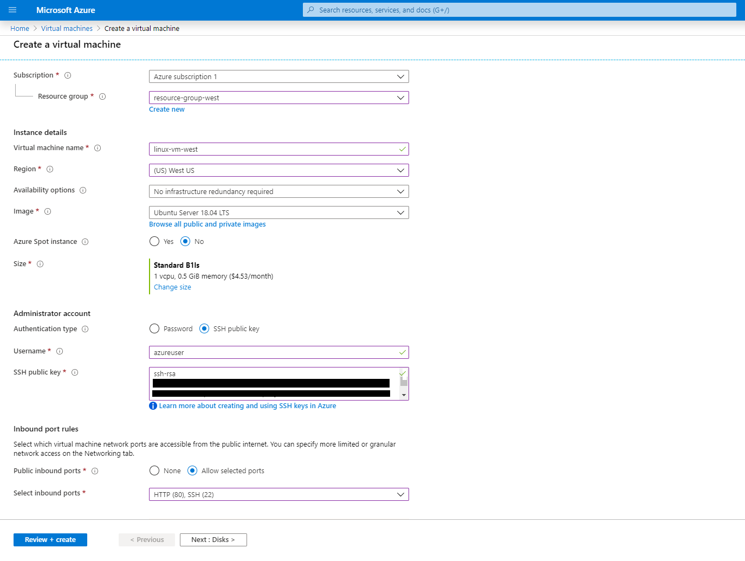

An example of creating a Linux VM in the Azure Portal

### Connecting to the VM

1. We'll need the admin username we set when creating the VM
2. We'll need the public IP address of our VM. You can use the following command to grab the IP address for a particular VM from the CLI. az vm list-ip-addresses -g resource-group-west -n linux-vm-west
3. Next we're going to copy a basic Flask app from my local machine to the VM. We'll be using the [secure copy utility](http://www.hypexr.org/linux_scp_help.php" \t "_blank). scp -r ./web udacityadmin@IPADDRESS:/home/udacityadmin
4. Now we can connect to the VM with “ssh [username]@[IP Address]” **Note**: Since we generated SSH keys, you won't be prompted for a password.
5. Run ls to see the web directory we just uploaded
6. Python 3 is already installed on the VM. We'll install Python Virtual Environment and NGNIX to use as a reverse proxy sudo apt-get -y update && sudo apt-get -y install nginx python3-venv
7. Before we run the app, we have to configure Nginx to redirect all incoming connections on port 80 to our app that is running on localhost port 3000
   * By default, Nginx has a default page that is displayed. If you visit the public IP address in your browser, you should see this page rendered.
   * We'll navigate to the **/etc/nginx/sites-available** directory—cd /etc/nginx/sites-available
   * We’ll first unlink the default site using sudo unlink /etc/nginx/sites-enabled/default
   * Then we’ll create a new file **reverse-proxy.conf** in **/etc/nginx/sites-available**—sudo vim reverse-proxy.conf
   * We're going to add the following code to this file:
8. **server** {
9. **listen** 80;
10. **location** / {
11. **proxy\_pass** http://localhost:3000;
12. **proxy\_http\_version** 1.1;
13. **proxy\_set\_header** Upgrade $http\_upgrade;
14. **proxy\_set\_header** Connection keep-alive;
15. **proxy\_set\_header** Host $host;
16. **proxy\_cache\_bypass** $http\_upgrade;
17. }
18. }
19. Now we’ll activate the directories by creating a sym link to the **/sites-enabled** directory sudo ln -s /etc/nginx/sites-available/reverse-proxy.conf /etc/nginx/sites-enabled/reverse-proxy.conf
    * We have to restart nginx so the changes take effect. sudo service nginx restart

### Deploying the App to the VM

This section is the same as the earlier walkthrough, so we'll skip a solution video for it.

To deploy the app on the virtual machine, I did the following:

1. CD to web
2. Create venv python3 -m venv venv
3. Activate the env source venv/bin/activate
4. Upgrade pip in our virtual environment and then Install dependencies—pip install --upgrade pip pip install -r requirements.txt
5. We'll run our app python application.py
6. In a web browser, we can visit the publicIpaddress
7. Type "exit" to disconnect from the VM

### Cleanup

If we no longer need a resource, we can delete them through the portal. The quickest way to do this from the CLI is to delete the resource group. This will delete all resources in that group

az group delete -n resource-group-west

# Creating an App Service

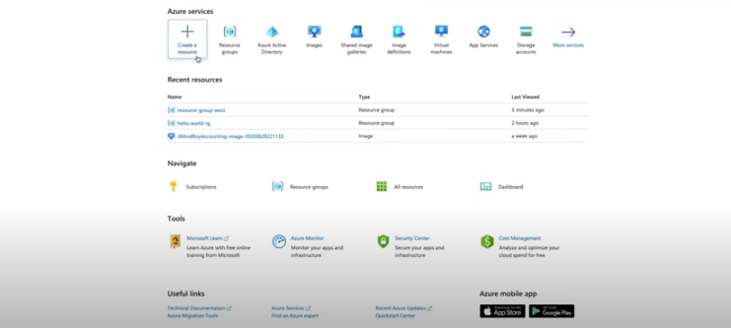

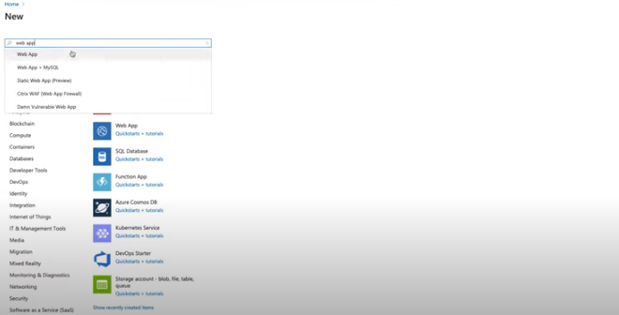

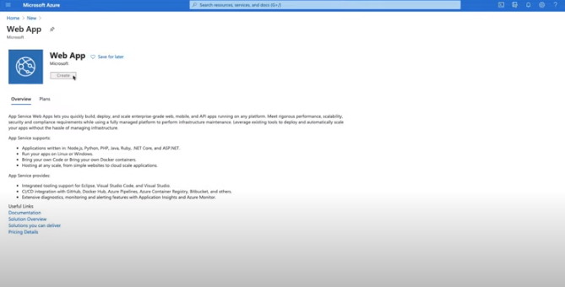

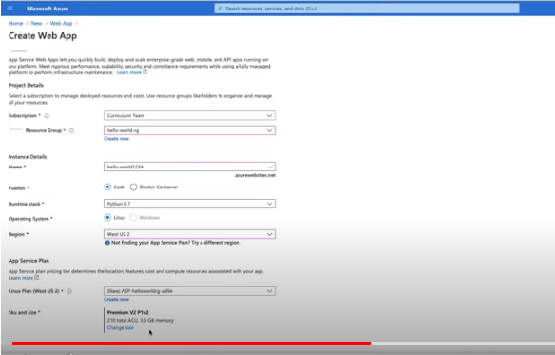

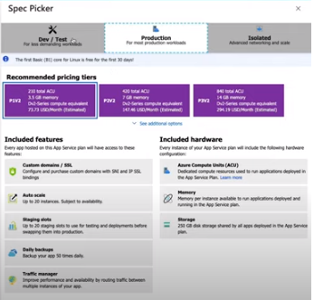

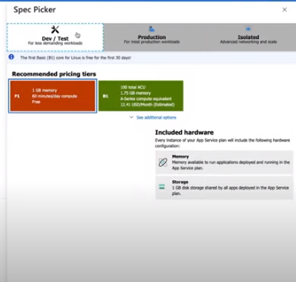

**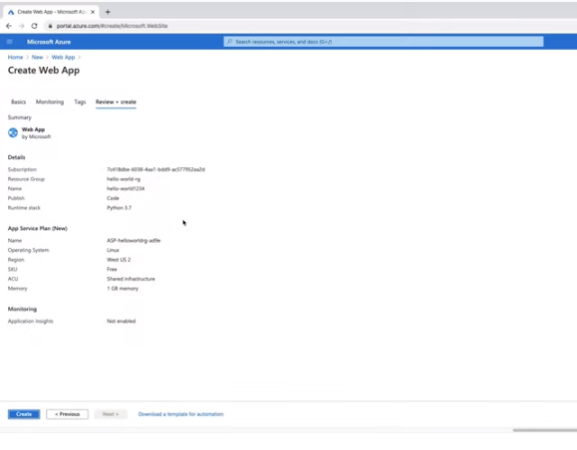**

**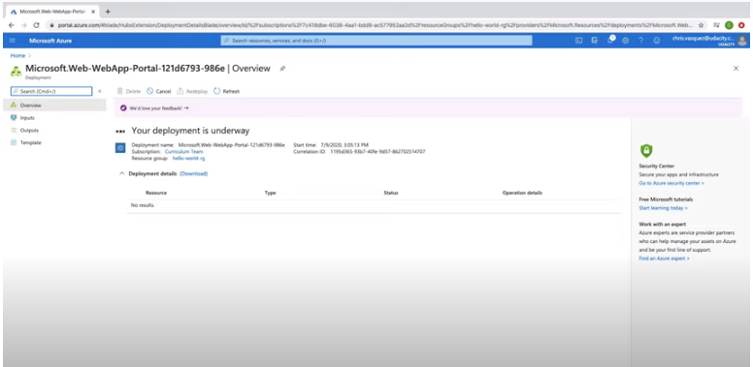**

**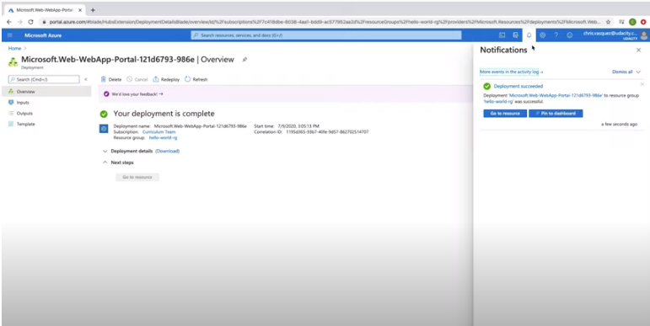**

**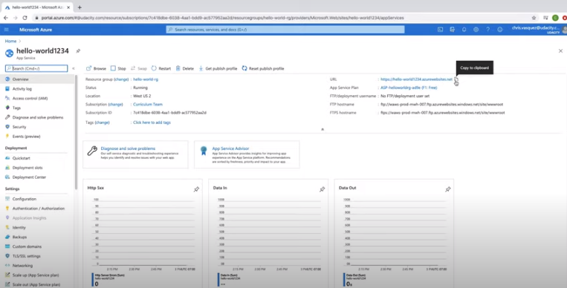**

**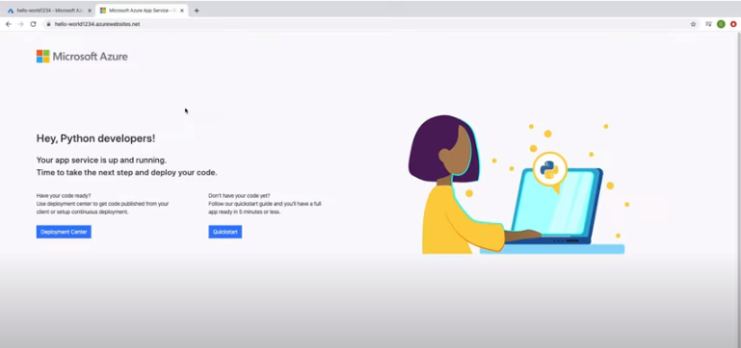**

I took the following steps to create an App Service Web App using the Azure Portal

1. On the homepage, click "Create a resource"
2. Search for "Web App"
3. Click "Create"
4. Select your subscription
5. Select your resource group "resource-group-west"
6. Enter a name for your web app—This needs to be a unique name and is unique to Azure as a whole and not just your Azure account. I used "hello-world1234" as my unique name.
7. For Publish, select "Code"
8. For the "Runtime Stack", select "Python 3.7" or greater.
9. For the "Operating System" select "Linux"
10. Select a region for your app service
11. Create a new App Service Plan. You can keep the default name Azure gives you or you can create your own name.
12. For SKU and size, select "F1" (Free).
13. Click "Review + Create"
14. Click "Create"

Then, I clicked on the URL to see the app service, which confirmed the app service was up and running. Now we need to deploy our code.

**Note:** Azure free account only allows 1 Linux App Service of size F1. You will need to delete the App Service Web App along with the App Service Plan after each exercise since we will create other Linux App Services throughout this course.

**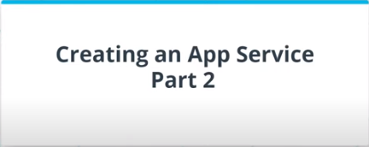**

**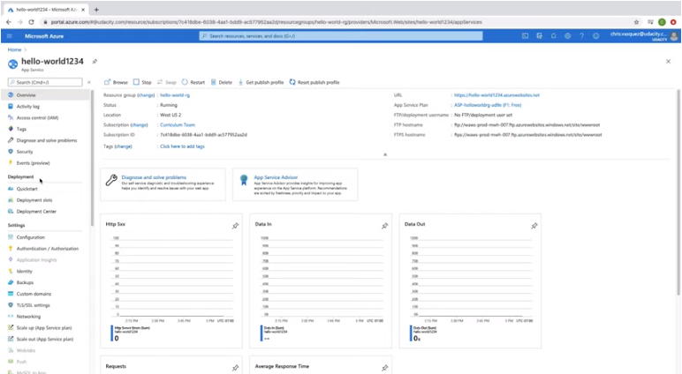**

**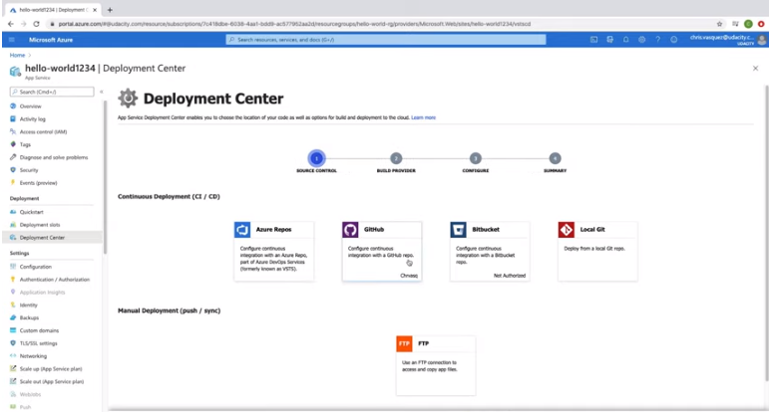**

**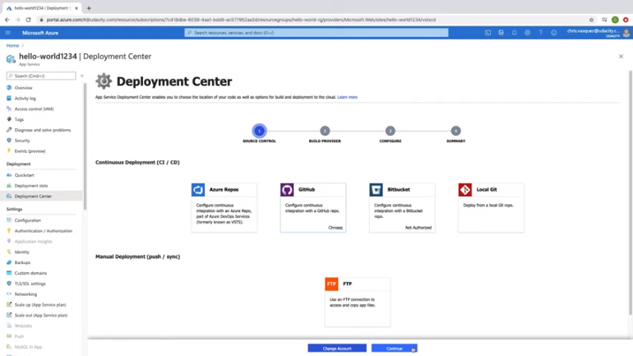**

**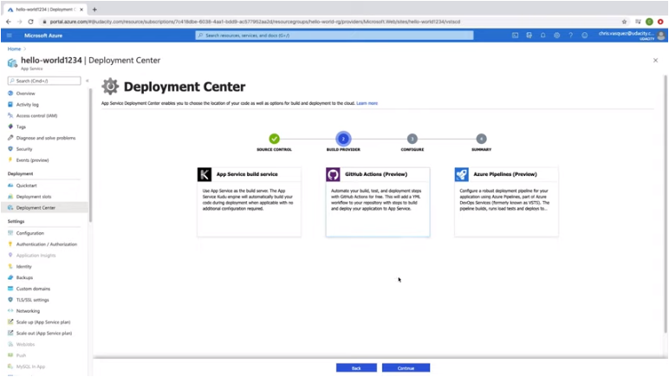**

**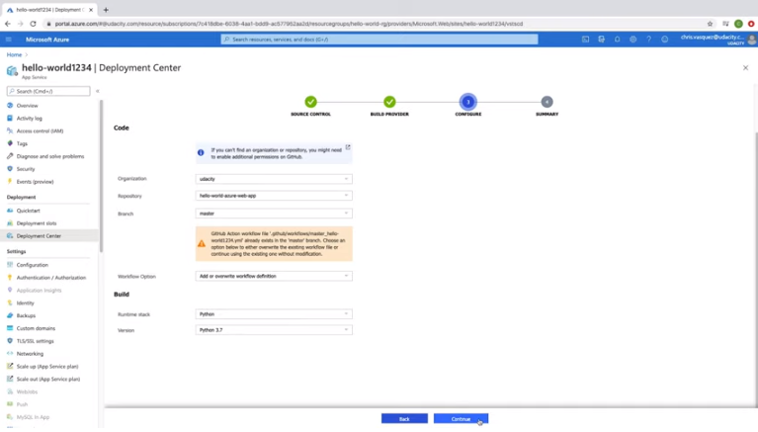**

**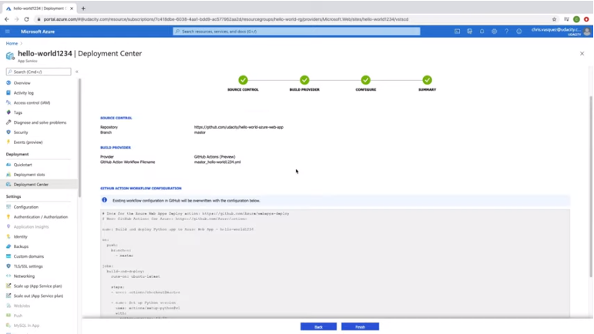**

**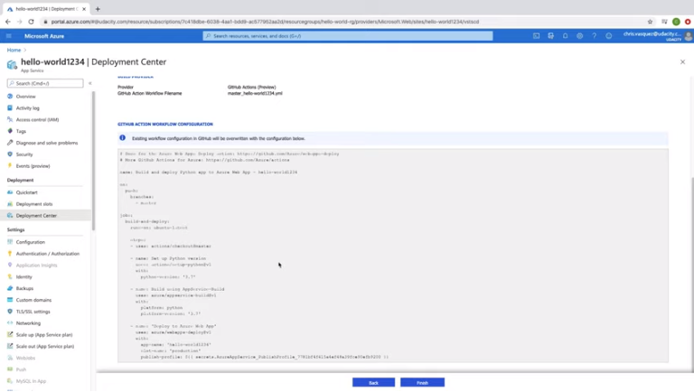**

**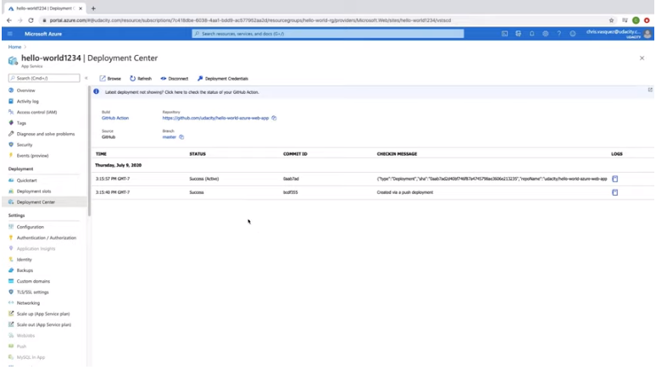**

**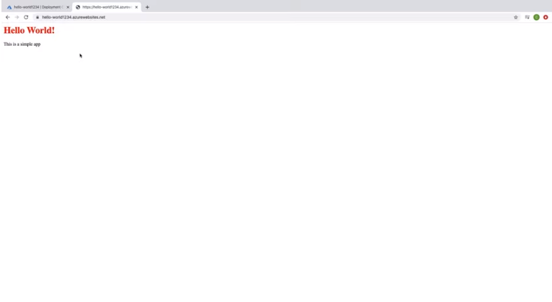**

To clean de resources:

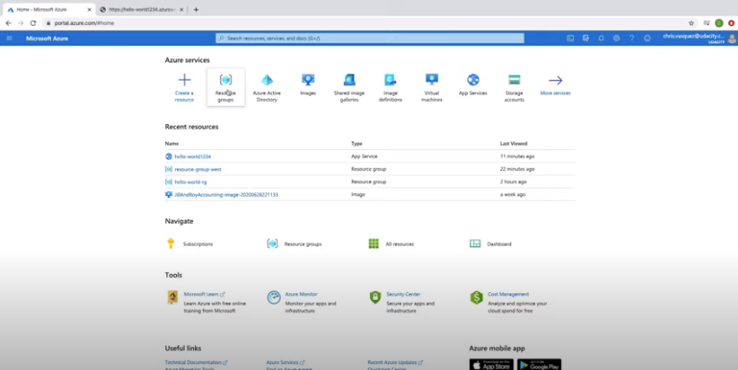

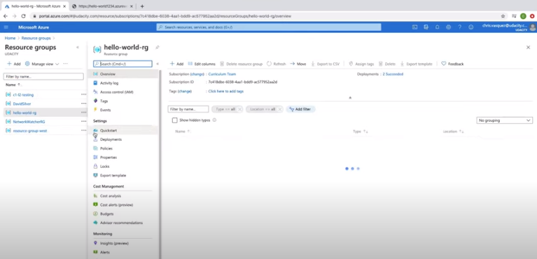

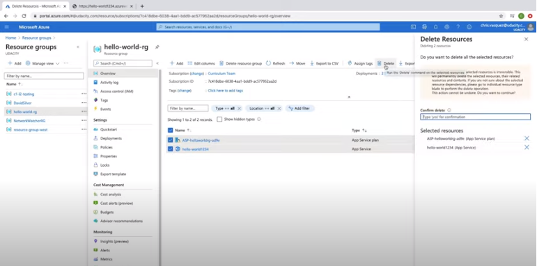

To deploy an App Service from a GitHub repository, I did the following:

1. Go to Deployment Center
2. Choose GitHub
3. Choose org and repo
4. Go through the prompts; deployment takes a few minutes
5. Go to URL of web app and should see the app deployed

### Cleanup

If we no longer need a resource, we can delete them through the portal.

1. From the homepage, click on "Resource Group".
2. Click on the resource group you want to manage.
3. You have two options—"Delete resource group" or if you want to keep the resource group, you can click on the individual or collection of resources you want to delete and click on "Delete".

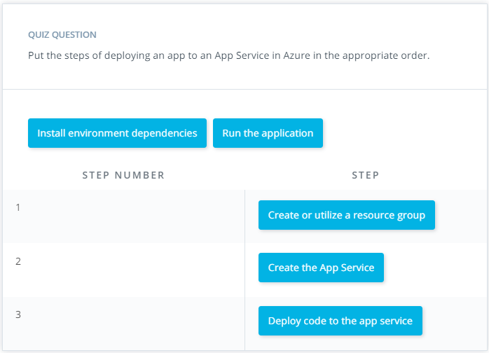

# Lesson Conclusion

In this lesson, we focused on Azure Compute Services:

* We took a look at some of the various compute options available
* Then, we discussed subscriptions and resource groups, and you created your own resource group
* From there, we took a deeper dive into two compute services in Azure: Virtual Machines and App Services
* After comparing and contrasting these two, you created both resources and deployed an app to them

# Glossary

| **Key Term** | **Definition** |
| --- | --- |
| Subscription | Multiple of these can exist within a single Azure account; often used for billing and other management purposes. |
| Resource Group | Help to organize resources you use, such as Virtual Machines, App Services or storage, in order to make resource management easier. Groups are often set up for different projects or regions. |
| Region | Locations of Azure data centers around the world. The closer the region of app resources is to the end user, the lower the latency experienced. |
| ARM Templates | Created within Azure Resource Manager to more easily spin up a set of given resources multiple times. |
| Virtual Machines | An Azure IaaS option giving you full access to the underlying operating system of a compute resource. These can be either Windows or Linux machines, with great availability, scalability and redundancy. These require more on-going maintenance and up-keep by cloud developers. |
| App Service | An Azure PaaS option allowing developers to focus more on their apps than the underlying infrastructure. It is an HTTP-based service for hosting web applications, REST APIs, and mobile back ends. It supports multiple languages and continuous deployment. While they are good for scaling, there is also a limit of up to 14 GB or 4 CPU cores on the highest tier. |
| App Service Plan | Contains certain settings of an App Service, such as region, number of VM instances (App Services still run on VMs, but the developer does not have control of the underlying VM, and the app may share the VM with other apps), size of those instances, and pricing tier. |
| Azure Batch | Used for running large-scale and high-performance compute applications beyond the capabilities of an App Service. |
| Azure Functions | A serverless, event-driven, compute-on-demand platform (covered in a later course). |
| Container Instances | A platform for deploying serverless docker containers (covered in a later course), without the container orchestration provided by AKS (see below). |
| Service Fabric | Microsoft's own distributed systems platform, similar to Kubernetes. |
| Azure Kubernetes Service (AKS) | Microsoft's own platform for hosting and managing Kubernetes, including deploying docker containers into clusters (covered in a later course). |

**LESSON 3 Azure Storage**

# Introduction

In this lesson, you will:

* Take a look at all the different storage options available in Azure and their benefits
* Take a deep dive on Azure SQL Databases and Blob Storage, including creating the related resources and uploading data
* Connect those storage services to your app

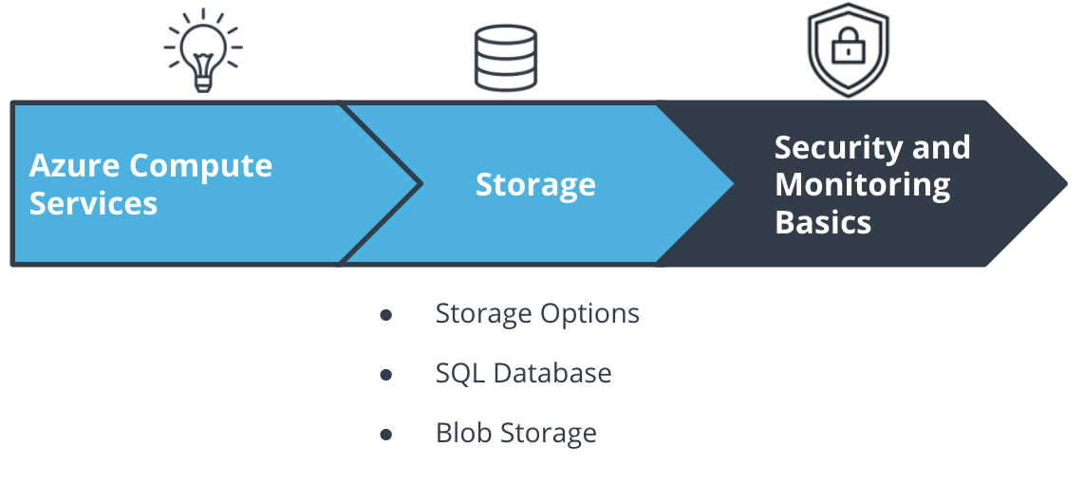

The Course and Lesson Outline

# Big Picture: Storage

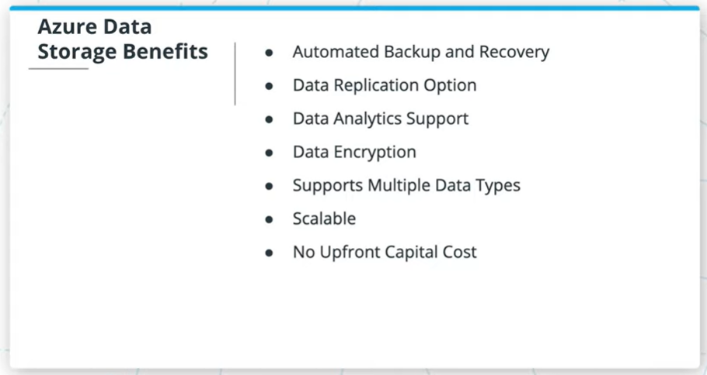

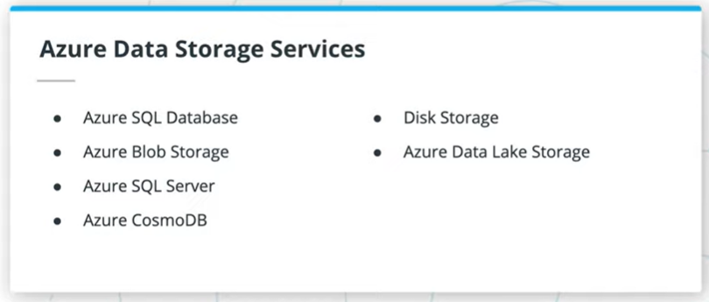

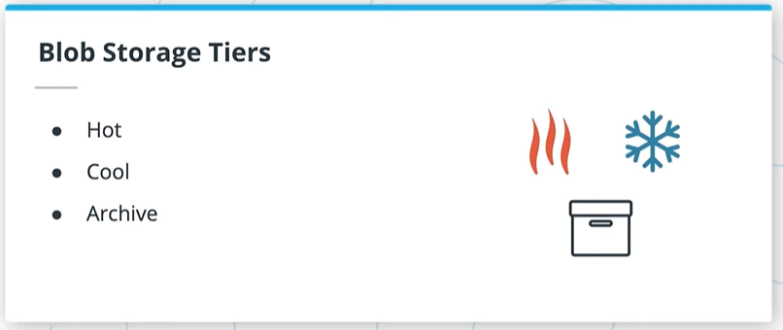

Some of the benefits of using Azure for storage are:

* Automated backup and recovery
* An option to replicate data at multiple data centers worldwide to help prevent outages from unplanned events, such as hardware failure.
* Data analytics support
* Data encryption for added security
* Support for the storage of multiple data types. Azure is designed to hold 3 main types data—relational data, non-relational data or NoSQL data, and unstructured data such as images.
* Scale up or scale out when demand is high and scale back when demand is low.
* Eliminate the expense of having to purchase, install, configure, and maintain on premises hardware.

### Azure Storage Options

Among others, some of the Azure Storage options are:

* Azure SQL Server and SQL Database
* Azure Blob Storage
* Azure CosmosDB
* Disk Storage
* Azure Data Lake Storage
* HPC Cache

We could spend an entire course just on Azure storage, so we’ll focus on two of these services in this lesson—Azure SQL Database and Azure Blob Storage. CosmosDB will be covered in another course.

We also covered the three tiers of blob storage - hot, cool and archive. We'll come back to this later in the section on Azure Blob Storage.

### QUIZ QUESTION

True or False: My app will only ever use one type of storage.

* 

True

* False

SUBMIT

**Azure SQL Databases**

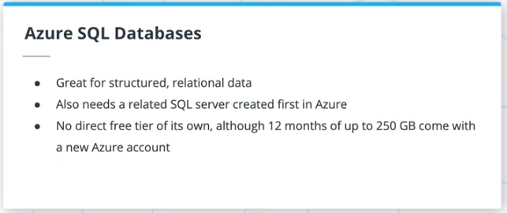

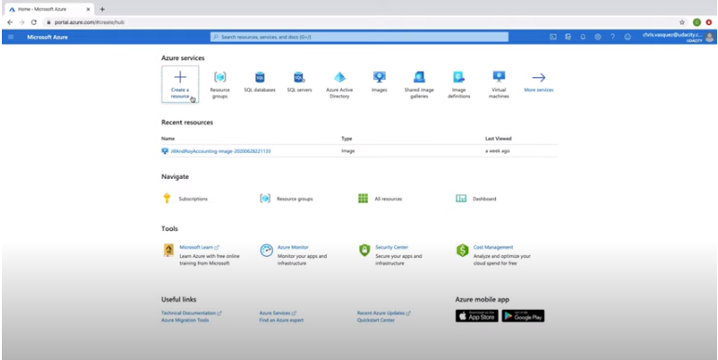

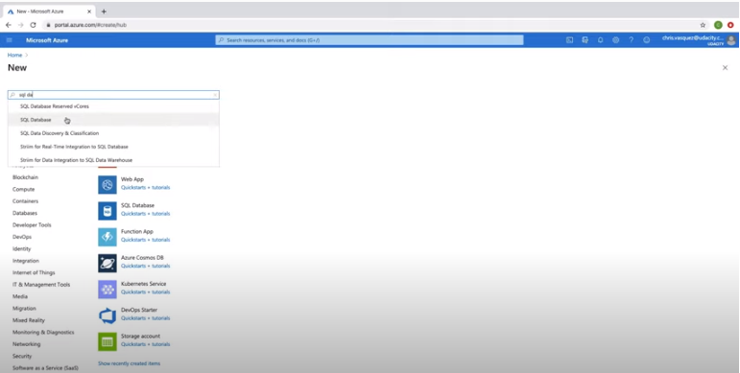

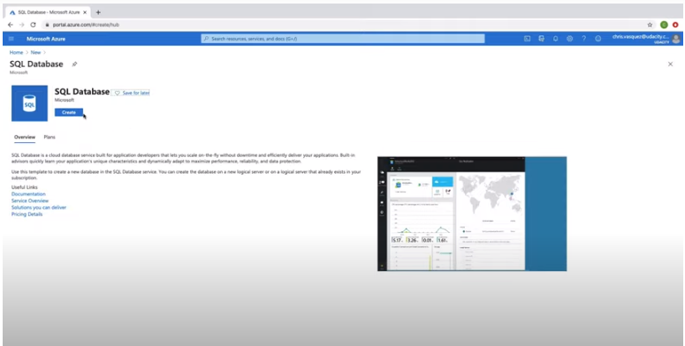

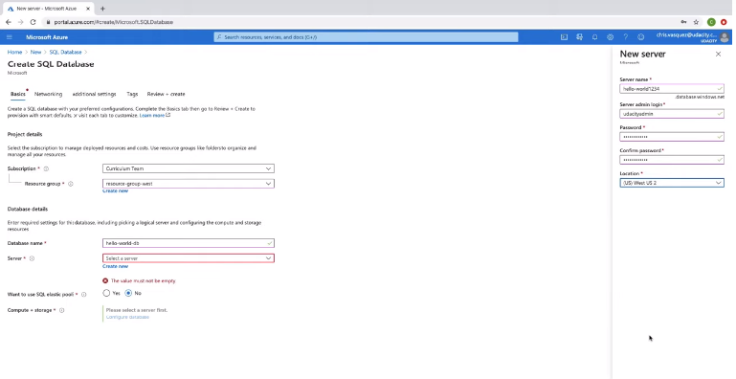

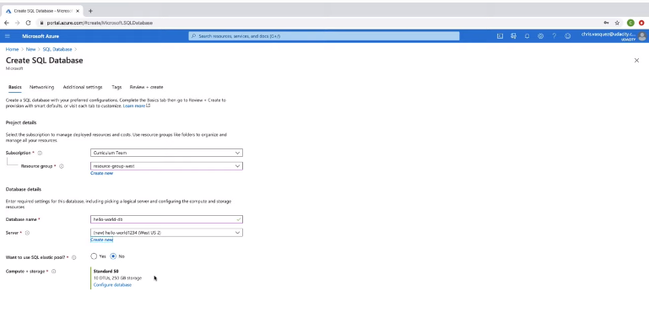

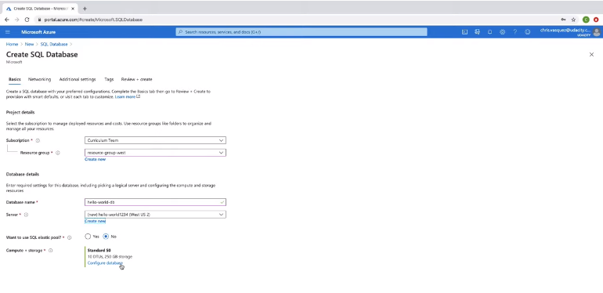

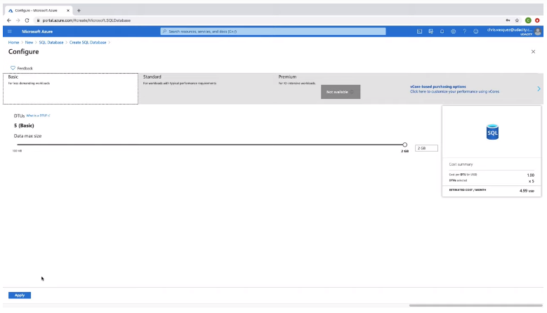

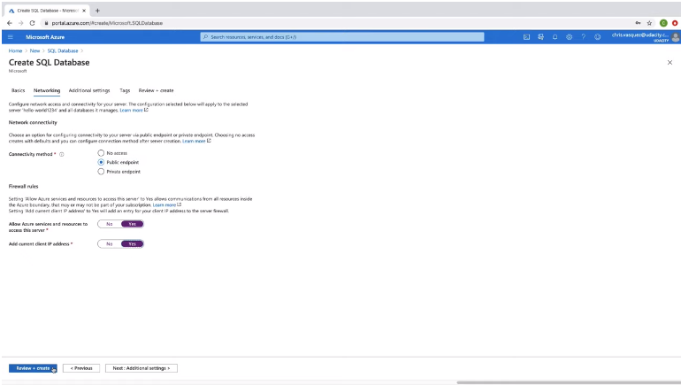

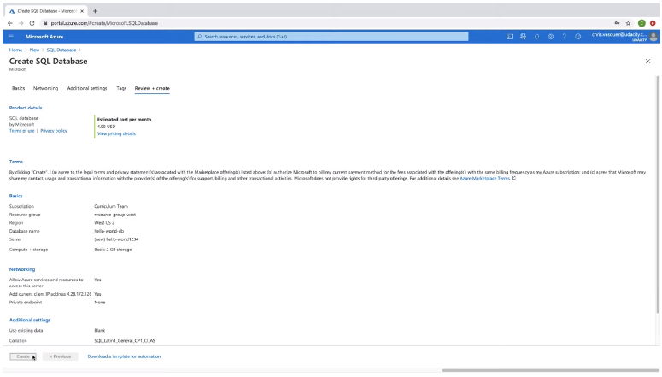

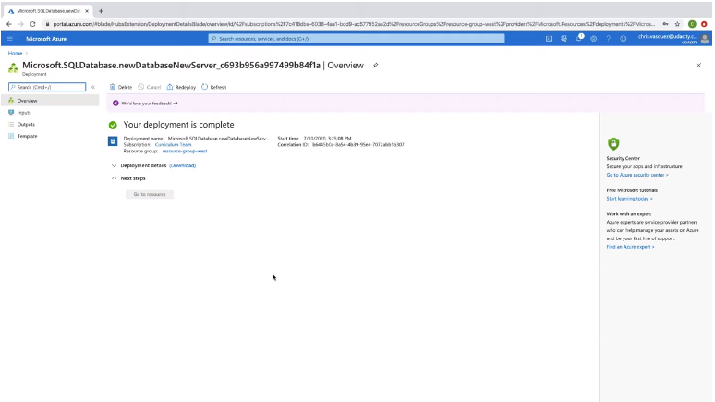

* Azure SQL databases are used for structured, relational data.
* In Azure, you also need to first create a related SQL server to hold the database, although you can create multiple SQL databases under a single SQL server.
* Azure SQL databases do not have a free tier option like we saw with App Services earlier; however, when you sign up for a new free Azure account, you get 12 months of up to 250GB of Azure SQL database storage. The lowest tier is currently ~$5 / month otherwise for a small amount of storage.

### Creating an Azure SQL Database in the Portal

To create an Azure SQL Database in the Azure Portal:

1. Find the "SQL databases" service in Azure.
2. Click "Create SQL Database".
3. Select the appropriate subscription and resource group (likely “resource-group-west”).
4. Enter a database name.
5. If you already have a SQL server, you can use it; however, you likely need to click "Create New".
   * If creating a new SQL server, enter a server name, and then admin and password - make sure you can remember these, or you will not be able to access the server when necessary. The admin name cannot just be "admin".
   * Set the location to match the resource group.
6. Keep SQL elastic pool on the default of "No".
7. Under Compute+Storage, click on "Configure Database". While General Purpose won't end up charging you anything for the short time the server is live for these exercises, you might as well press "Looking for basic, standard, premium?", and change it to "Basic".
8. Press the "Next: Networking" button, then select "Public Endpoint", and set both of the Firewall rules that appear to "Yes". This will allow us to more easily access the SQL database later on within our app.
9. Click "Review + Create" and then "Create" to create the database, then wait for it to deploy.

### QUIZ QUESTION

Azure SQL Databases can be left up on the basic tier for no cost forever.

* 

True

* False

SUBMIT

# Adding Data to the Database

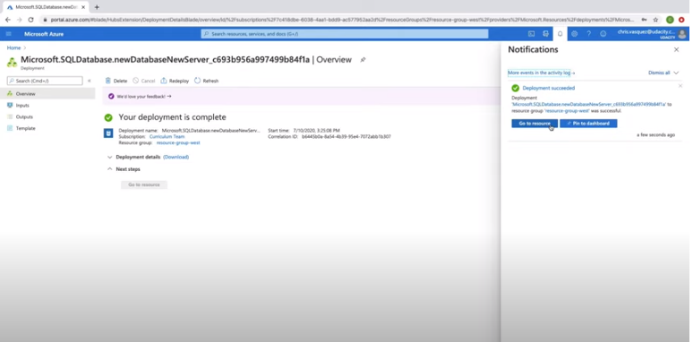

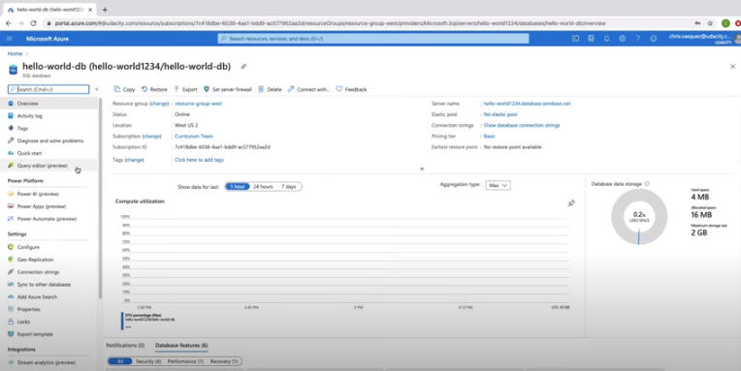

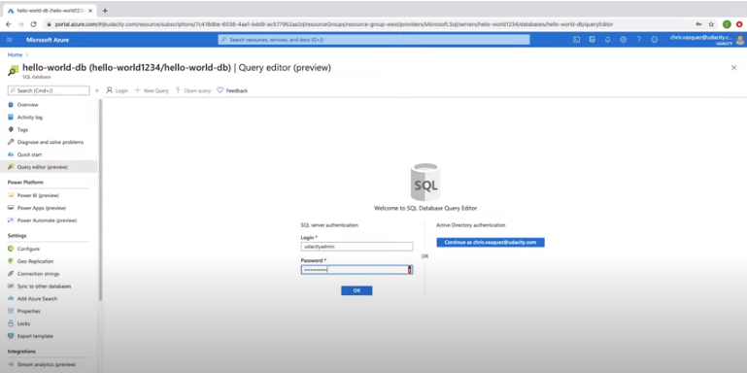

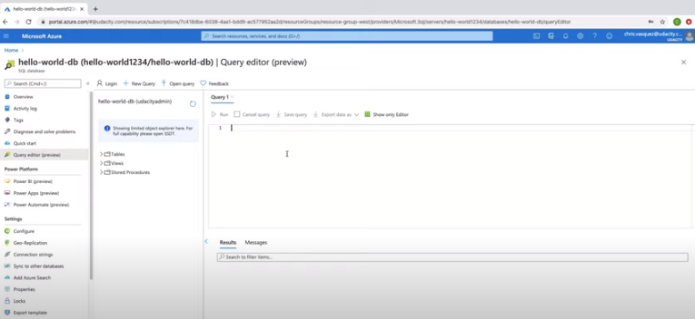

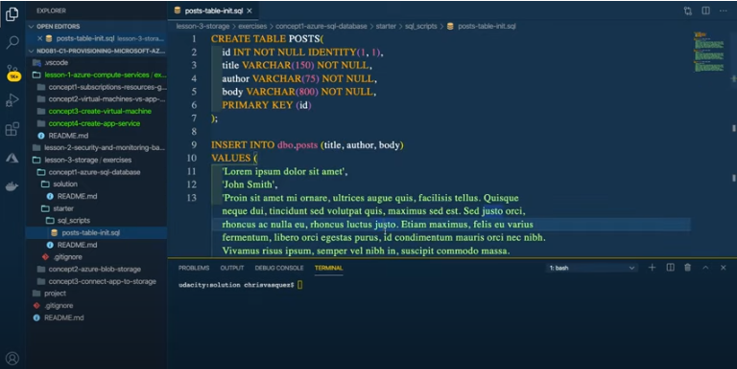

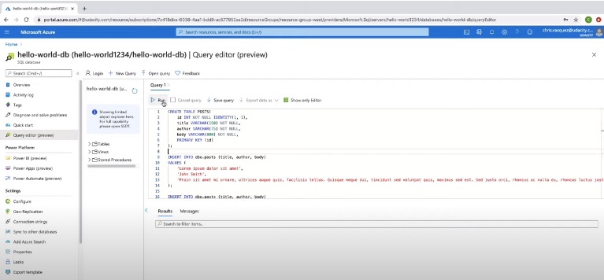

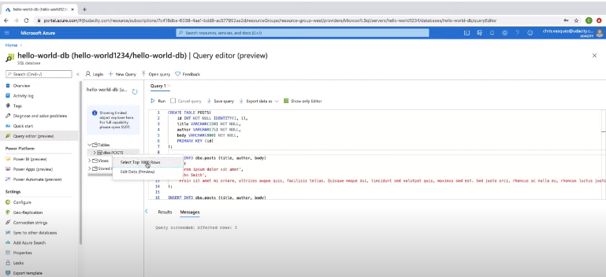

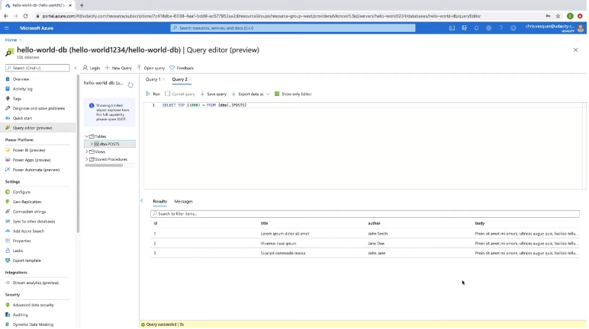

The last step is to delete the resources to don’t be charged.

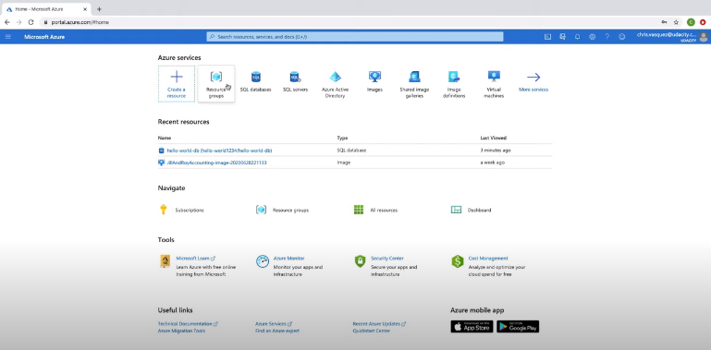

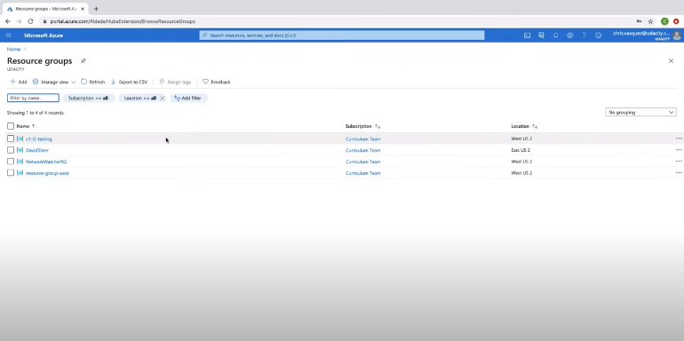

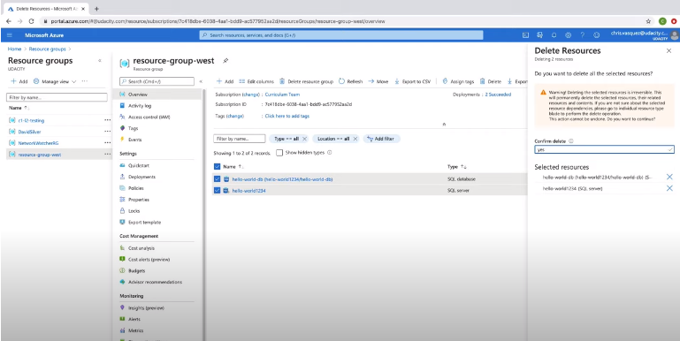

To add data to the SQL Database, I performed the following:

1. Once the SQL database is deployed, click on its name to access it (you may need to go back to the main "SQL databases" page in Azure).
2. Click on the "Query editor" in the left side menu, and then log in with my SQL Server credentials.
3. I pasted the query from my posts-table-init.sql script into the query window, and hit "Run"; you should see Query succeeded: Affected rows: 3.
4. On the left side of the query window, I clicked on the "Tables" folder, and double-checked that the dbo.POSTS table was successfully created with the correct fields.
5. I ran a new query with SELECT \* FROM posts, to see the three posts listed.

You'll get to practice this yourself in the upcoming exercise.

### QUIZ QUESTION

Which of the following would be appropriate data to store in a SQL database?

* Information about books like author, title, year published, and summary
* 

Unstructured event data

* 

Images or code repositories

* Sales invoices, such as id, price, and item quantities

# Exercise: Azure SQL Databases

## Exercise: Azure SQL Databases

In this exercise, you will create an Azure SQL Database and add data to it. This is an [Azure account first-year free service](https://azure.microsoft.com/en-us/free/free-account-faq/). In a later exercise, you will connect an app to the database, so that you can both get and post data from the app into the database.

1. Deploy a SQL Database in Azure called “database-west” to the “resource-group-west” resource group (or whichever resource group you have been using in earlier exercises).
2. Within the Azure portal, add the data from the script in the sql\_scripts directory [here](https://video.udacity-data.com/topher/2020/July/5f075d26_sql-scripts/sql-scripts.zip) to the database. You should be able to run a SELECT query afterward on the animals table to see the example animals populated in your database.

**Note**: Azure free accounts only allow 250GB of free storage using SQL Databases. Once you get to the end of this lesson, you will want to delete the SQL Database and SQL Server to avoid incurring any charges, as you'll create a different SQL Database in the final course project.

#### Supporting Materials

* [sql-scripts.zip](https://video.udacity-data.com/topher/2020/July/5f075d26_sql-scripts/sql-scripts.zip)